Join the Somerset Community Palliative Care ECHO network

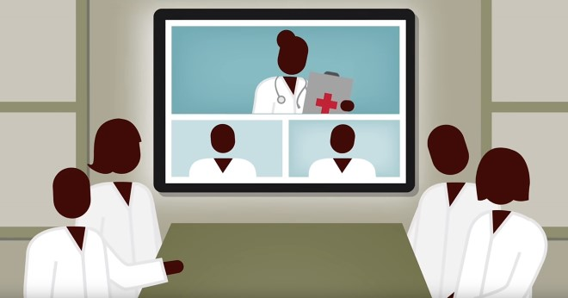

Are you a Health or Social Care Professional interested in developing your knowledge of Palliative Care?

Project ECHO is an innovative model which uses Zoom video conferencing technology to link health and social care professionals with the hospice. This saves on travel time and provides a forum where a variety of participants can share best practice and learning - all staff from signed up teams are welcome.

Signed up teams will have access to:
- 60 minute FREE facilitated remote sessions (monthly)
- teaching presentations by specialists and care studies
- the opportunity to share knowledge and network with other professionals in Somerset
- support from a variety of specialists in palliative care
- certificate of attendance

All you need is a device that you can access the internet and emails on, with a camera, microphone and speaker. No special software is needed - a link will be sent in an e mail that allows you to join the session directly.

For more information and to sign up, please contact:
Nigella Bruce (ECHO Coordinator): 01823 346956
ECHO@st-margarets-hospice.org.uk

