Quiz for HCAs performing spirometry + reversibility @ WMC
- What demographics are used to calculate a persons predicted range for spirometry?
Age, Height, Gender,Ethnicity
- For what reasons would you not complete a spirometry test?
Patient has a contra – indication, the test has not been officially requested by either
A GP or resp consultant, Patient is not well enough to perform the test
- What is the maximum recommended attempts allowed for the FVC manoeuvre?
X 8 attempts
- What 2 things need to be checked before Salbutamol reversibility is performed?
If the patient has a drug allergy to Salbutamol, If the Salbutamol PSD has been added to the patients notes
Please draw on the charts below to show how the following would appear
( 1) A slow start to expiration (2) An expiration ending early (3) A patient coughing during expiration (4) Patient not providing maximum effort
( 1) (2)
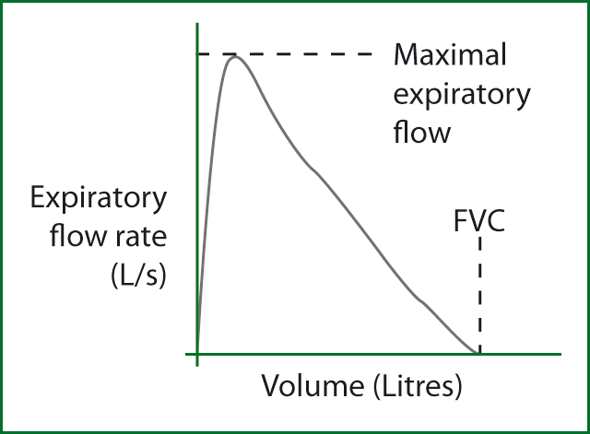
(3) (4)

