1

The CARE CERTIFICATE

Basic Life
Support

What you need to know

1
2

Standard

THE CARE CERTIFICATE WORKBOOK

Legislation and basic life support

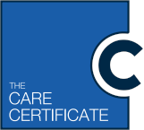
Introduction

THE CARE CERTIFICATE WORKBOOK STANDARD 12
2

The information in standard
12 provides knowledge about the administration of basic life support.

You should be provided with practical training by your employer to be able to put this knowledge into practice in order to be able to carry out basic life support competently.

Completion of this standard will not provide you with the competence to become a
first aider. In order to achieve this you would be required to undertake specific first aid qualifications within your workplace. The qualification will be dependent on your job role and your employer’s assessment of first aid needs.

Basic Life Support (BLS)

Basic life support comprises the following elements:

• Initial assessment
• Airway maintenance
• Cardiopulmonary Resuscitation (CPR).

When a casualty is unconscious we need to establish if they are breathing normally or not breathing. This is achieved by opening and maintaining the airway.

When approaching a casualty, an initial casualty assessment should be conducted; this initial assessment is called a primary survey. The primary survey is a systematic process of approaching, identifying and dealing with immediate and/or life-threatening conditions. The primary survey can be remembered by the acronym DRSABCD (or the easy way to remember; Doctors ABCD).

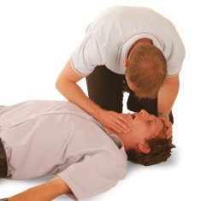
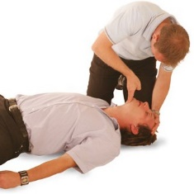
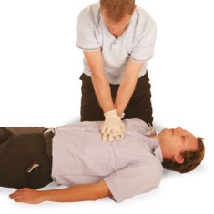
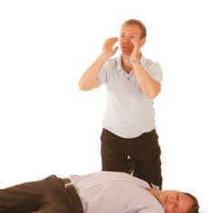
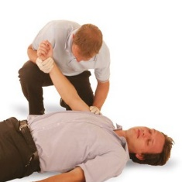
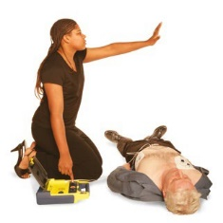
If aRe
Prior to approaching the casualty, ensure the scene is safe to do so.
If possible, approach the casualty from their feet as this prevents hyperextension of the neck from a responsive casualty. Use the ABPU scale when checking for a response.

The P in AVPU is sometimes also referred to pain depending on the scale used.
If you are on your own do not leave the casualty at this stage.
With an unresponsive casualty open their airway using the head – tilt – chin lift method.
After opening the airway look, listen and feel for normal breathing for no more than 10 seconds.

Helpful Hint: Agonal Gasps Present in 40% of cardiac arrest victims not to be mistaken for normal breathing.
Casualty not breathing

Commence CPR (30 compressions, 2 breaths.

Casualty Breathing
Check for bleeding and consider putting in the recovery position.
If available an AED (Automated External Defibrillator) should be used alongside CPR.
A – Alert is the casualty moving/talking? No – proceed to V
V- Voice – does the casualty respond to speech? – No – proceed to P
P – Place – place your hand on the casualty’s shoulder and gently shake them. Ask loudly Are you alright/ No response proceed to U.
U – Unresponsive – assume the casualty is unresponsive

Danger
Shout for help
CPR/ Circulation
Response
Breathing
Airways
Defibrillation

Cardiopulmonary resuscitation (CPR)

Cardiopulmonary resuscitation (CPR) should be administered to a casualty who is not breathing normally (and no signs of life). CPR is a method of combining chest compressions with effective rescue breaths in order to artificially circulates blood and to put air into the lungs. The depth of compressions is as follows:

• Adult – 5 – 6 centimetres (similar to the height of a credit card) using both hands
• Child (1 year to onset of puberty) – Compress at least one third of the chest’s depth, using one hand
• Infant (0-1 years of age) – Compress at least one third of the chest’s depth, using two fingers.

The rate of compression should be 100-120 compressions per minute. 30 chest compressions should be administered prior to moving on to breaths (expired air ventilation).

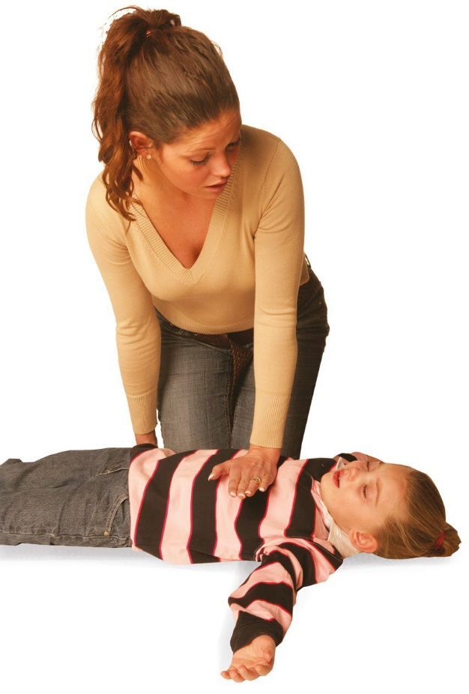
After completing 30 chest compressions two effective breaths should be administered. Each breath should take one second to complete and the casualty’s chest should rise as in normal breathing; this is known as effective rescue breathing. Or in the case of an infant, from the infant’s mouth and nose. Turn your head and watch the chest rise and fall, then administer the second breath.

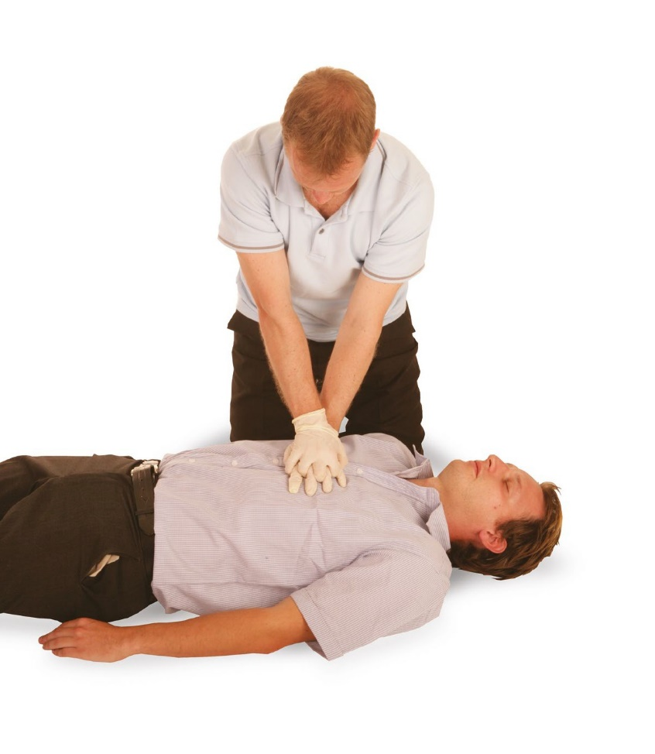

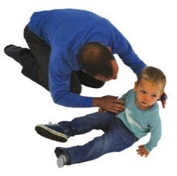
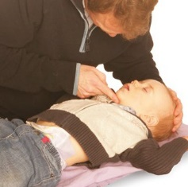
Danger | Response | Shout | Airways | Breathing | CPR/Circulation | Defibrillation
Prior to approaching the child or infant, ensure the scene is safe to do so. | If you are on your own do not leave the child or infant. | If you are on your own do not leave the child or infant. | Open the airway using the head-tilt- chin-lift method. Position airway in a neutral position and in a child slightly extended.  Helpful Hint  Use 1 finger to lift the chin to open the airway of an infant. | After opening the airway look, listen and feel for normal breathing for no more than 10 seconds.  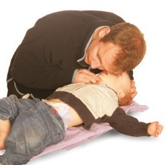  If the casualty is not breathing call  999/112.  Helpful Hint  If the casualty is not breathing and you are on your own give 5 initial breaths followed by 1 minute of CPR before making the call yourself. | Infant/child not breathing Administer 5 initial breaths Commence CPR  (30 compressions  2 breaths). If no help has arrived within 1 min, call  999/112.  Casualty breathing Check for bleeding. Call 999/112.  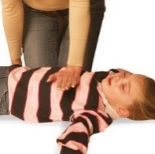  Helpful Hint  For chest compressions: Infant – 2 fingers Child – 1 hand (dependant on the size of the child). | The use of an AED is not recommended on infants less than 1 year old.  An AED with paediatric pads should be used on children aged 1-8 years of age.  For children aged  8 years and over standard AED pads are suitable if available and trained to use.
Infant  • Talk to the infant  • Gently tap their shoulders and tickle  soles of feet  • If a response is gained move onto  ‘Priorities of Paediatric First Aid Treatment’ followed by a Secondary Survey  • Phone for medical assistance. |  | Child  • Talk to the child  • Gently tap their shoulders and ask  “Are you alright?”  • If a response is gained move onto  ‘Priorities of Paediatric First Aid Treatment’ followed by a Secondary Survey  • Phone for medical assistance.

The respiratory system

The main aim of the respiratory system is to supply oxygen to all parts of the body. Breathing is essential to life. When we inhale we breathe in a mixture of:

• Nitrogen (79%)
• Oxygen (20%)
• Other gases (1%).

When we exhale we breathe out a mixture of:

• Carbon dioxide (4%)
• Nitrogen (79%)
• Oxygen (16%)
• Other gases (1%).

Obstructed airway (adult)

The obstruction of the airway can be due to different causes including foreign bodies (foods), allergic reactions, asthma, blood, vomit and infections. An obstruction can cause minor or major breathing difficulties and, in severe circumstances, may cause the casualty to become unconscious and unresponsive.

Someone who is choking will have either a partial or complete obstruction of the airway. The severity of the blockage will determine the difficulty in breathing.

Recognition

• Grasping at the throat area
• Difficulty in breathing and speaking
• Difficulty in crying or making a noise
• Redness of the face
• Eyes enlarged and watering
• Displaying distress.

Treatment

• This should not be carried out by any worker who has not successfully completed formal practical training provided by their employer
• Encourage the casualty to lean forward and cough, if the obstruction remains
• Administer a maximum of 5 sharp back blows, if the obstruction still remains
• Administer a maximum of 5 abdominal thrusts (chest thrusts for an infant), if the obstruction remains
• Repeat the cycle a further two times (3 cycles in total)
• If after three cycles the obstruction still remains, shout for help, contact the emergency services and be prepared to carry out basic life support (CPR).

Obstructed airway (infant and child)

An obstruction can cause minor or major breathing difficulties and, in severe circumstances, may cause the infant or child to become unconscious or unresponsive.

Recognising a choking infant or child

• Grasping at the throat area
• Difficulty in breathing and speaking (in the case of a child)
• Difficulty in crying or making a noise
• Redness of the face
• Eyes enlarged and watering
• Displaying distress.

With a complete obstruction the infant or child may show the above signs but also the skin colour may develop a blue/grey tinge; they will get progressively weaker and eventually they will become unconscious.

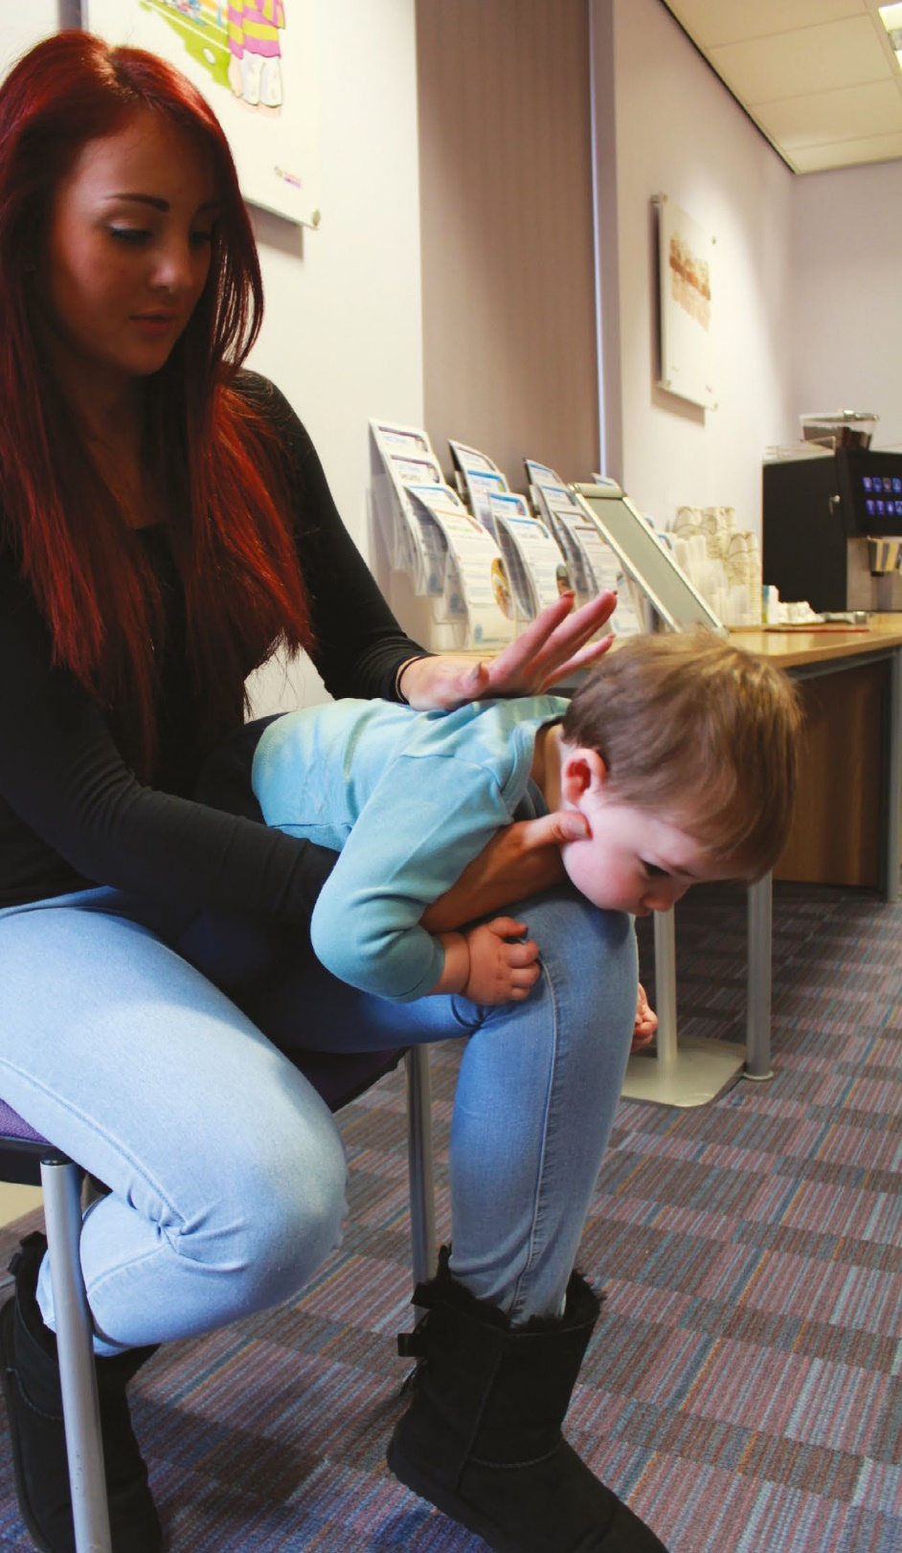
Treating a choking infant

THE CARE CERTIFICATE WORKBOOK

Back blows

• Shout for help
• Look into the infants mouth and remove any visible objects (if
they are easily accessible, do not perform a blind finger sweep)
• Place the infant in a downward facing position with the infants head at the lowest point. Support the infants head by making a cradle
with your fingers and thumb of one hand supporting the infant’s lower jaw
• The palm of the hand supports the infant’s chest and the trailing arm supports the infant’s body
• Administer a maximum of 5 sharp back blows with the other hand (the heel of the hand should strike inbetween the infant’s shoulder blades).

Chest thrusts

• If, after five sharp back blows the obstruction still remains, then carefully turn the infant over to face you, once again, ensuring that the head is below chest level and administer a maximum of five chest thrusts; use two fingers to carry this out (chest thrusts are similar to chest compressions but should be administered more slowly and sharply)
• Check the infant between each chest thrust and if the obstruction is cleared then cease administering chest thrusts immediately
• If after three cycles of administering back blows and chest thrusts, the obstruction
is still present, contact the emergency services and continue with the cycles of back blows and chest thrusts
• If the infant becomes unresponsive then place on a firm flat surface and be prepared to carry out CPR.

Helpful Hint

Under no circumstances should abdominal thrusts be performed on an infant. These must be replaced with chest thrusts.

Treating a choking child

Encourage the child to cough. If coughing clears the obstruction, monitor the child. If after coughing the obstruction still remains and the child is choking, then administer up to a maximum of 5 back blows.

Back blows

• Lean the child forward (supporting the upper chest with one hand)
• Administer a maximum of five sharp back blows with the other hand (the heel of the hand should strike inbetween the child’s shoulder blades)
• If, after five sharp back blows the obstruction still remains, then administer up to a maximum of five abdominal thrusts.

Abdominal thrusts

• Stand or kneel behind the child, lean them forward and place your arms and hands around their waist
• Make a clenched fist with one hand and place the thumb of the clenched fist above the navel
• Cup the clenched fist with the other hand and thrust inwards and upwards sharply in one motion
• Repeat this procedure up to a maximum of five times
• Check the child between each abdominal thrust and if the obstruction is cleared then cease administering abdominal thrusts immediately
• If after 3 cycles of administering back blows and abdominal thrusts, the obstruction is still present, contact the emergency services and continue with the cycles of back blows and abdominal thrusts
• If the child becomes unresponsive then place on a firm flat surface and be prepared to carry out CPR.

Helpful Hint

If the child is small it may be beneficial to lay the child across your knee in order to administer back blows. Children should be taken to seek medical attention if they have received abdominal thrusts or if they have difficulty in swallowing or still feel as though they have an object stuck in their throat, even with a cleared obstruction.

Confidentiality

All confidential information regarding infants, children and individuals must be kept securely and only accessible or available to those who have a right to access them. Anyone who is responsible for the storage of records and information must be aware of their responsibilities under the Data Protection Act (DPA) 1998 and, if relevant, the Freedom of Information Act (FOI) 2000.

Record keeping

Depending on your specific job role, there will be information and records that will require completing should an infant, child or adult be involved in an accident, or become ill whilst in the health and social care setting.
This recorded information in the accident book can:

• Help to identify trends
• Help to control health and safety risks
• Be used for reference in future first aid needs assessments
• Prove useful for investigations.

Please refer to your employer policy and procedures and forms. If you need further clarity, speak with your manager

Refresher training

Refresher training should be conducted regulary.

1

The CARE CERTIFICATE

Basic Life
Support
(In General Practice)

What do you know now?

1
2

Standard

THE CARE CERTIFICATE WORKBOOK

Complete the following
sentence with the missing words:

Practical
Competently
Knowledge

Employer
Practice

You should be provided with training by your

to be able to put this into and in order to be

able to carry out basic life support .

below can you find two of them? (Place a tick beside the two):
List - This term means to identify the
main points which can be written as bullet points

Initial assessment (primary survey)

Expired air ventilations

Secondary survey

Airway maintenance

Recovery position

the correct description on
the right:

Danger
We need to open this to check for breathing

Response
We need to check for no more than 10 seconds for this

Shout
This should be used alongside CPR

Airway
Prior to approaching the casualty visually check the area for ……

Breathing
If not breathing commence …

CPR/Circulation
Use the ‘AVPU’ scale when checking for this

Defibrillation
The action carried out if the casualty is not responsive

Answer the question by
filling in the blanks using the numbers provided:

100 - 120
10
20

2
30
12
999/112

1. Seconds to take to check normal breathing

2. Rate of compressions given per minute during CPR

3. Number of breaths given in a cycle of CPR

4. Number dialled for ambulance services

5. Percentage of oxygen in the air that we breathe
Activity 12.5

Know your Practice Equipment and Procedures

You need to know where your Practice keeps the emergency equipment, and what action you must take if there is an emergency within the Practice.

Complete the following
1. How will you summon help or be summoned to assist if an emergency occurs within the Practice?
Answer……………………………………………………………………………………………………………………………………………………………………………….
2. Where is the emergency box kept?
Answer ……………………………………………………………………………..
3. Who is responsible for checking the emergency equipment and how often does this occur?
Answer…………………………………………………………………………………
4. Many Practices now have a defibrillator on site. If there is one at your place of work where is it kept and is it accessible by everyone (including visitors) on site?
Answer…………………………………………………………………………………….........

Care Certificate progress log, mapping and sign-off document

Standard Number: 12 Standard Title: Basic Life Support

Document guidance
This document provides an overview of the outcomes and assessment criteria for Standard 12: Basic Life Support. It identifies the criteria within the Standard that should have been achieved upon successful completion of the underpinning knowledge within the Care Certificate workbook. Employees must demonstrate their competence in practice in order to fully achieve this Standard of the Care Certificate.

This progress log and sign-off document should be completed jointly by the employee and the manager/supervisor/assessor to confirm that all outcomes and criteria have been achieved in practice in the work setting. Supplementary evidence can be attached to demonstrate achievement and it is suggested to do so as good practice.

This document also provides an outline of the suggested mapping of outcomes and criteria within Standard 11: Basic Life Support of the Care Certificate to the recommended Qualifications and Credit Framework (QCF) unit, the National Minimum Training Standards for Healthcare Support Workers and Adult Social Care Workers in England and the Common Induction Standards. This document does not necessarily indicate direct mapping of criteria and therefore assessors and/
or managers should ensure they follow the guidance below. Please note that when the term assessor is used throughout this document this could be the manager, supervisor or assessor and will be decided by the employing organisation.

This document should always be used in conjunction with the guidance provided in the Care Certificate Framework Technical Document.

Guidance for assessors
Assessors must ensure that the learner has produced evidence for each assessment criterion that is valid, authentic, reliable, current and sufficient. Therefore assessors must not assume that if the mapping document indicates a criterion could have already been achieved, the mapped criteria within the QCF unit should automatically be awarded. Learners and assessors are responsible for ensuring that the outcomes and criteria within the QCF unit and standards below have been achieved to the required standard. For reference, within the column that refers to coverage of the relevant QCF unit, a P indicates that the Care Certificate criteria provides partial coverage of the relevant criteria within the QCF unit, whereas an F indicates full coverage.

The Assessment method used column is included to allow assessors to provide evidence of the type of assessment method that has been used to assess the Care Certificate criteria. This is likely to be noted as the Care Certificate Workbook, however if further evidence is also provided this could include professional discussion, observation, question and answer, e-learning, witness testimony etc. This column can also be completed to evidence competency using these example assessment methods.

The Evidence location column is included to provide a clear signpost to where the learner’s evidence can be found. This may be within a portfolio of evidence, a continued professional development (CPD) file or electronically via e-learning or e-portfolio.

Unit number | Unit title | Level | Credit
L/602/5058 | Basic adult life support and automated external defibrillation | 2 | 2

THE CARE CERTIFICATE WORKBOOK STANDARD 12

Care Certificate  Standard 12  Outcome | Care Certificate Standard 12  Criteria | Knowledge/ Competence | Question within workbook | QCF unit  L/602/5058  Basic adult life support and automated external defibrillation | National Minimum Training Standards  N/A | Common Induction Standards  N/A | Assessment method used | Evidence location | Sign-off initials | Date
12.1 Provide basic life support | Be able to carry out basic life support.  Complete practical Basic Life Support Training that meets the UK Resuscitation Council guidelines.  • If working with adults in health and social care they will undertake training in adult basic life support.  • If working with paediatric patients in health they will undertake training in paediatric basic life support.  • If working with newborn patients in health they will undertake training in newborn life support.  Guidance:  • Resuscitation Council 2010  Resuscitation Guidelines  • Cardiopulmonary Resuscitation  – Standards for clinical practice and training joint statement | K&C | N/A | Learners are provided with basic life  support underpinning knowledge within  the Care Certificate Workbook in addition to completion of relevant training for their workplace. The knowledge and skills gained may provide mapping to the basic adult life support and automated external defibrillation unit.

THE CARE CERTIFICATE WORKBOOK STANDARD 12
17

Declaration of completion
I confirm that the evidence provided by the employee meets the full requirements for Standard 12: Basic Life Support.

Employee signature: Name of assessor*: Assessor* signature:
Completion date:

*The Assessor can be your Manager, Supervisor or someone else authorised by your employing organisation. This individual provides confirmation that all learning
outcomes and assessment criteria for the Care Certificate standard identified above have been completed and signed off by an authorising person.

THE CARE CERTIFICATE WORKBOOK STANDARD 12
18

