The CARE CERTIFICATE

Fluids and
Nutrition

What you need to know

THE CARE CERTIFICATE WORKBOOK
Standard8

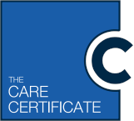

Fluids and nutrition and food safety
What we eat is vital to our health and wellbeing and how we look,
feel and function. It is important that people have a diet that is safe to
eat and has all the nutrients they need. Food safety is essential when preparing and handling food.

Not all substances and objects that can cause harm or illness can be seen. This means that people can become ill from eating food that tastes normal and looks safe. Whether you are making someone a snack such as a sandwich or are regularly involved in preparing meals you should make sure that the food is safe to eat.

Contaminated
If something becomes contaminated it means it will become dirty, infected, unclean
o r polluted.

Food must be prepared and stored in ways that prevent it becoming contaminated with things that can cause harm or illness. Food hazards could be:

•

• Physical – such as objects that can be harmful, for example bones or bits of packaging. These could be in food when bought or introduced when preparing food. Check for these as far as is possible
• Chemical - such as pesticides, weedkillers or cleaning chemicals that could be harmful if eaten, for example pesticides attached to fresh fruit and vegetables or cleaning products sprayed onto prepared foods. Ensure all fruit and vegetables are washed before preparation and avoid spraying cleaning products close to food
• Allergenic - such as those that may cause extreme reactions if an individual is allergic to the food, for example nuts, shellfish, milk or gluten. They may cause an itchy skin rash, breathing problems and/or stomach cramps with vomiting or
diarrhoea. In the worst case the person may go into an anaphylactic shock. Always ensure foods that contain allergens are kept and prepared separately from foods that do not
• Bacterial – such as pathogenic micro-organisms in food, for example raw foods that need to be cooked to remove the pathogens, or those found in the human gut, nose and mouth that can be transferred to food during the storage, handling and preparation process. Effective food safety principles should be followed to remove these risks.

Anaphylactic shock
A severe and potentially life-threatening reaction to an allergy. Symptoms may
include swollen hands, feet or eyelids, trouble with breathing and/or collapse and unconsciousness.

Pathogenic micro-organisms
These are harmful germs that can be found in food and which can enter the body
and grow or multiply causing infection and illness.

Legislation which came into force on 13 December 2014 that sets out how food businesses deal with allergen information. This legislation applies to all organisations that provide food, including care and healthcare providers covering pre-packed and non-pre- packed foods. Providers are required legally required to provide a warning if foods contain
1 of the 14 allergenic substances that are covered by the legislation. Information on the changes can be found here:
www.food.gov.uk/science/allergy-intolerance/label/labelling-changes

Vulnerable
Vulnerable individuals are more likely to
be affected because a smaller number of bacteria can cause illness, and the symptoms individuals experience may be more severe. This could be due to a variety of reasons.

Some groups of people are more vulnerable to food-related illnesses because of a weakened immune system. These groups can include:
• Babies, toddlers, children and teenagers: as immunity develops throughout our lives, the older we get the more immune we become to germs
• Pregnant and breastfeeding women: as childbearing and breastfeeding uses up a lot of the body’s iron and zinc which are important for immunity
• Elderly people; their immune system becomes less effective in recognising contaminated food
• Those who are living on a low income: they find it difficult to afford a healthy and balanced diet
• People in prison: through exposure to infectious diseases like tuberculosis and hepatitis C
• People in hospital: as illness weakens the immune system, and some medication may also affect the immune system.

It is essential that precautions are taken to ensure that food is safe to eat. There are some basic principles you need to keep in mind to protect all individuals when handling, storing or preparing food, these include:

• Remove jewellery before preparing food
• Wash your hands thoroughly before touching food
• Wash equipment in hot water between uses
• Ensure food is cooked thoroughly
• Store food in sealed containers and keep cooled
• Food stored in a fridge should be labelled, dated and kept at 5ºC
• Store raw meat below cooked food
• Prepare raw and cooked foods separately
• Equipment should be washed in hot soapy water or dishwasher if available.

The Care Quality Commission requires that where food is provided to individuals that it is handled, stored, prepared and delivered in a way that meets the requirements of the Food Safety Act 1990. If your role includes preparing or handling food, you must have the knowledge and skills to do so safely. Your manager will identify any training that you require.

The importance of good nutrition and hydration in maintaining health and wellbeing

The food and drink that we have must provide the nutrients that our bodies need to work properly. To stay healthy we need a diet that includes the correct balance of the following:

Carbohydrates
These provide most of the energy that we need. That includes energy for the basic actions that keep us alive (called the Basal Metabolic Rate) - for example, keeping the heart beating, enabling breathing, keeping blood circulating and for the production of hormones and enzymes and new tissues. Examples are bread, potatoes, rice or pasta.
Vitamins
These support many different functions, including blood clotting, maintaining an effective immune system, and allowing the body to absorb energy from foods. Fruit and vegetables are good sources of vitamins.

Minerals
Calcium, which helps to build strong bones and teeth and iron, which helps the blood to carry oxygen around the body. Milk products are good providers of calcium and liver and shellfish are full of iron.
Fibre
This promotes a healthy bowel and helps to remove waste products from the body. Fruit, vegetables, wholemeal bread, nuts and seeds are high in fibre.

Protein
This is important for the body’s cells and tissues to be repaired and replaced. You will find protein in milk products but also in meat, fish or beans.

A diet that does not include the right balance of everything we need can lead to illness and ill-health. A healthy, balanced diet will give an individual the nutrients their body needs to function properly.

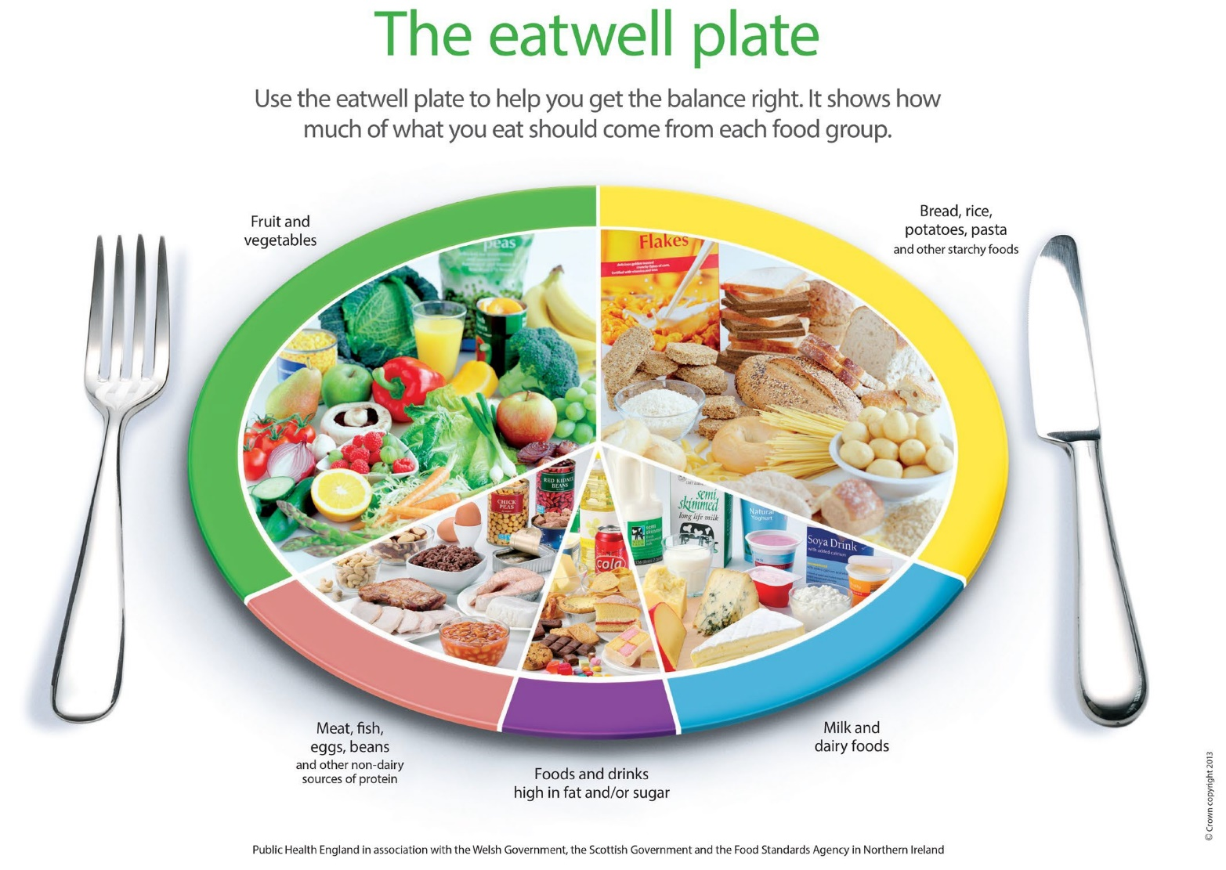
The eatwell plate has been developed by Public Health England in association with the Welsh and Scottish Governments and the Food Standards Agency in Northern Ireland. It is the model used widely in the UK to illustrate a healthy diet and is suitable for most groups of people. It shows the five main food groups and the proportions of each food group recommended as part of a daily healthy diet.

The food groups include:

• Fruit and vegetables
• Bread, rice, potatoes, pasta and other starchy foods
• Meat, fish, eggs, beans and other non-dairy sources of protein
• Milk and dairy foods
• Foods and drinks high in fat and/or sugar.

Fluid is essential for life. Without enough fluid the body cannot carry out basic processes that enable it to function correctly. For example:

• Digesting food and enabling nutrients to be absorbed
• Enabling blood to circulate around the body
• Removing waste products via urine and faeces
• Keeping cells and tissues moist, helping to avoid infection
• Controlling body temperature by perspiration
• Maintaining brain function.

It is recommended that individuals should have about 1.5-2 litres of fluid each day or 6-8 cups or glasses. Most ordinary drinks (for example, fruit juices, milk, tea and coffee in moderation and low sugar drinks) count as fluid but lots of alcohol can lead to dehydration. The best fluid to rehydrate the body is water. Some medical conditions, such as certain types of heart condition or kidney disease will require individuals to drink less. There are times when an individual must not eat or drink anything for a set period of time, for example before an operation. This is known as nil-by-mouth and will be clearly shown in their care plan. This must be followed for their own safety. An individual's exact fluid requirements will be in their care plan and should be referred to when providing care and support.

Signs and symptoms of poor nutrition and hydration

Statistics suggest that around a third of people admitted to hospital or care in the UK
are malnourished or at risk of becoming so. Signs and symptoms that a person is not having the correct balance of nutrients include:

Malnourished
The term malnourished means that an individual's diet does not contain the right balance of nutrients it needs to function properly. This could include under nutrition, when a person does not get enough nutrients or over nutrition, when a person has more nutrients than they need.

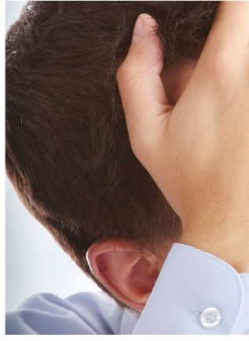
• Muscle weakness
• Feeling tired all the time
• Increased infections
• More falls
• Constipation
• Lack of energy
• Gaining or losing weight
• Changes in behaviour
• Depression
• Poor wound healing.
Early signs and symptoms of dehydration include:
Signs and symptoms
These give us the first clues
that an individual may be experiencing malnutrition.

• Feelings of thirst as the body tries to increase fluid levels
• Dark coloured urine as it tries to reduce fluid loss
• Headaches, tiredness and confusion, as the flow of blood to the brain decreases. (These signs might also indicate an undiagnosed health problem, for example type 2 diabetes.)

Ongoing dehydration can contribute to:
• Constipation
• Urinary tract infections, which are prevalent in some groups in care
• Kidney stones and infections
• Poor wound healing.
If dehydration remains untreated, it can have serious consequences. Blood circulation can be affected or kidneys can fail.

Promoting adequate nutrition and hydration

When people receive any type of care or support (particularly long term care) an assessment should be made about their nutrition and hydration. This should include food allergies, likes and dislikes and the support they need to eat and drink. Information should also include things like whether they have their own teeth and, if not, can they eat normally or do they need soft food?

It is important to work in person centred ways and to provide food which is suitable and that meets their individual needs. If they have arthritis in the hands they may need help with cutting up food or opening packs like yogurts. Do they have beliefs or preferences that affect the foods that they eat? Are there any foods they should not have because of medication? For example, some people on certain medications for depression should not have cheese. Some individuals choose not to eat certain foods, for example, if they are vegetarians or vegans, so it is important that you know what this means. For example those who are vegans do not eat dairy foods. Are there any foods they should not have because of health conditions? For example:

• People with raised blood cholesterol levels may be advised not to have too much saturated fat such as butter, fried items and pastry
• People with diabetes may be encouraged to avoid too much sugar found in sweets, chocolate, sugared breakfast cereals, cakes and puddings and encouraged to eat fewer of these or smaller portions.
• Those who have high blood pressure may be advised to limit salt
• Anyone who is obese should be encouraged to limit sugary and fatty foods.

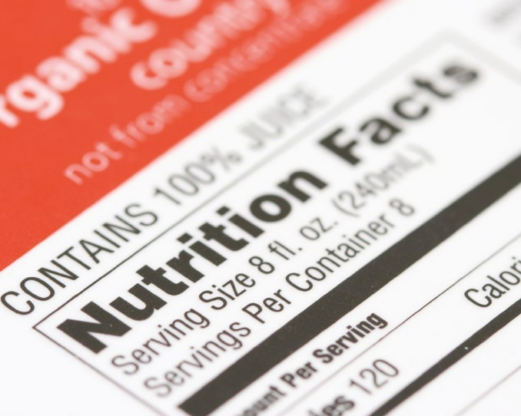
Some individuals might experience difficulties in eating or drinking without help. This may be due to:

• Forgetting to eat (perhaps due to dementia)
• Side effects of medication which may affect appetite or cause sickness
• Poorly fitting false teeth
• Physical illness such as a stroke which may have affected the individuals muscles around their mouth for chewing or hand for lifting drinks
• Depression which may cause poor appetite
• A visual impairment which may affect the way a person sees their food to eat it
• Poorly fitting false teeth.

Equipment is available to support people in eating and drinking independently including:

• Technology such as clocks or reminder messages to tell someone when it is time to eat or drink
• Cutlery with shaped and padded handles that can help with gripping
• Two-handled mugs to help people with poor grip, tremors or weak wrists.
• Cups with lids to reduce the risk of spillage
• One-way straws that help people to drink without the need to lift cups and glasses, even if muscle weakness has reduced their ability to suck
• Non-slip mats which stop plates from moving around while people are cutting food
• Plates and bowls with high sides to prevent food falling off the edges or insulated bowls which keep the food hot if the individual needs longer to eat

It is important that individuals are treated with dignity and respect. They should have plenty of time to eat, not be rushed and be able to choose whether they would like to use any equipment offered. If you have concerns that an individual is not eating or drinking enough despite being encouraged and supported, you should discuss your concerns with your manager who may seek advice from a specialist such as a dietician or a nutritionist. They will ensure that additional support can be provided. This might include:

• Closer monitoring of nutrition and fluid intake
• Talking to the person to identify any barriers to eating and drinking
• Emphasising that good nutrition and hydration are important
• Discussing the problem with the person’s carer or family member
• Consulting with other workers such as doctors, therapists or dentists.

Compassion
All individual needs should be respected and a person should be treated in a
compassionate way to help maintain adequate nutrition and hydration.

Supporting individuals to have access to fluids, food and nutrition in accordance with their care plan

Providing for nutrition and hydration must be carried out in a person centred way. Efforts must be made to meet each individual’s needs and choices. Their care plan is an essential part of recording and delivering this.

Individuals should have access to fluid at all times, unless it is restricted for medical reasons. They should be encouraged to drink throughout the day and not wait
until they feel thirsty, as feelings of thirst are an early sign of dehydration. To make sure that individuals are drinking enough you need to offer drinks and encourage and support them to drink as set out in their care plan. Drinks need to
be refreshed regularly and placed within easy reach for those with restricted movement or mobility. If you are at all concerned about an individual’s fluid intake, make sure you report these concerns to either a senior member of staff, the individual’s carer or their family.

Food provided should be in accordance with an individual’s care plan and ensure that cultural preference, health conditions and allergen advice is followed. Food safety principles need to be applied when storing, preparing and handling food. If the care plan states that they need encouragement, or help and support with eating, this needs to be provided. Food needs to be served at the right temperature and within easy reach. If an individual needs specific utensils to eat independently, these need to be available too. As with concerns about fluid intake, any worries about an individual’s food or nutrition should be shared with a senior member of staff, the individual’s carer or their family.

The CARE CERTIFICATE

Fluids and
Nutrition
(In General Practice)

What do you know now?

THE CARE CERTIFICATE WORKBOOK
Standard 8

Activity 8.1a

Certain groups of people are more vulnerable to the effects of eating food that has been contaminated.
List 4 of these vulnerable groups of people.

List - this term means to identify the main points which can be written as bullet points.

Basic principles of food safety

1.

2.

3.

4.

Activity 8. 1a

Part ii) Thinking about where you work, describe why being aware of food safety and hygiene is so important

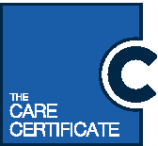

Describe - to describe means to create a picture with words but not simply writing
a list of bullet points.

Activity 8.1b

Part i)
Explain the importance of good nutrition and hydration in maintaining health and wellbeing. Make sure you include the following in your answer:

Explain - to explain something you will need to provide a clear account of your understanding, including details like why and how.

Fibre
Carbohydrates
Balance

Eatwell Plate
Protein
Vitamins
Plate V

Bodily Functions
Minerals
Bodily functions

Activity 8.1b

Part ii)

What is the recommended daily amount of fluid an individual must consume to support good hydration? | ………………...litres | How many 150ml glasses would an individual have  to consume to reach the minimum recommended amount? | …………......glasses

Activity 8.1c

Part i) Complete the diagram below to list the signs and symptoms of malnutrition:

List - this term means to identify the main points which can be written as bullet points.

Signs and symptoms of malnutrition

Activity 8.1c

Part ii) Complete the diagram below to list the signs and symptoms of dehydration:

List - this term means to identify the main points which can be written as bullet points.

Signs and symptoms of dehydration

Activity 8.1d

As a healthcare support worker in General Practice you are required to promote good nutrition and hydration.
For each of the examples below explain what action you would take in the situation given

Explain - to explain something you will need to provide a clear account of your understanding, including details like why and how.

Situation | Action you would take
It is very warm and a patient tells you their fridge has broken down and they are waiting for a relative to come at the weekend to fix it.
An elderly patient who attends for a health check hands you a urine sample that looks very dark and concentrated.
A patient with dementia attends on a very warm day wearing lots of layers of clothing.

Care Certificate progress log, mapping and sign-off document

Standard Number: 8 Standard Title: Fluids and nutrition

Document guidance
This document provides an overview of the outcomes and assessment criteria for Standard 8: Fluids and nutrition. It identifies the criteria within the Standard that should have been achieved upon successful completion of the underpinning knowledge within the Care Certificate workbook. Employees must demonstrate their competence
in practice in order to fully achieve this Standard of the Care Certificate.

This progress log and sign-off document should be completed jointly by the employee and the manager/supervisor/assessor to confirm that all outcomes and criteria have been achieved in practice in the work setting. Supplementary evidence can be attached to demonstrate achievement and it is suggested to do so as good practice.

This document also provides an outline of the suggested mapping of outcomes and criteria within Standard 8: Fluids and nutrition of the Care Certificate to the recommended Qualifications and Credit Framework (QCF) unit, the National Minimum Training Standards for Healthcare Support Workers and Adult Social Care Workers in England and the Common Induction Standards. This document does not necessarily indicate direct mapping of criteria and therefore assessors and/
or managers should ensure they follow the guidance below. Please note that when the term assessor is used throughout this document this could be the manager, supervisor or assessor and will be decided by the employing organisation.

This document should always be used in conjunction with the guidance provided in the Care Certificate Framework Technical Document.

Guidance for assessors
Assessors must ensure that the learner has produced evidence for each assessment criterion that is valid, authentic, reliable, current and sufficient. Therefore assessors must not assume that if the mapping document indicates a criterion could have already been achieved, the mapped criteria within the QCF unit should automatically be awarded. Learners and assessors are responsible for ensuring that the outcomes and criteria within the QCF unit and standards below have been achieved to the required standard. For reference, within the column that refers to coverage of the relevant QCF unit, a P indicates that the Care Certificate criteria provides partial coverage of the relevant criteria within the QCF unit, whereas an F indicates full coverage.

The Assessment method used column is included to allow assessors to provide evidence of the type of assessment method that has been used to assess the Care Certificate criteria. This is likely to be noted as the Care Certificate Workbook, however if further evidence is also provided this could include professional discussion, observation, question and answer, e-learning, witness testimony etc. This column can also be completed to evidence competency using these example assessment methods.

The Evidence location column is included to provide a clear signpost to where the learner’s evidence can be found. This may be within a portfolio of evidence, a continued professional development (CPD) file or electronically via e-learning or e-portfolio.

Unit number | Unit title | Level | Credit
M/601/8054 | Support individuals to eat and drink | 2 | 2

Care Certificate  Standard 8  Outcome | Care Certificate  Standard 8 Criteria | Knowledge/ Competence | Question within workbook | QCF unit: Support individuals to  eat and drink (M/601/8054) P = Partial  F = Full | National Minimum Training Standards: Standard 8  – Health and safety | Common Induction Standards: Standard 8 – Health and safety in an adult social care workplace | Assessment method used | Evidence location | Sign-off initials | Date
8.1 Understand the principles  of hydration, nutrition and food safety | 8.1a Describe the importance of food safety, including hygiene, in the preparation and handling of food | K | 8.1a part i  8.1a part ii |  | 8.10.1 | S8 – 11.1
 | 8.1b Explain the importance of good nutrition and hydration in  maintaining health and wellbeing | K | 8.1b part i  8.1b part ii | AC5.1 - P | 8.10.2 | S8 – 11.2
 | 8.1c List signs and symptoms of poor nutrition and hydration | K | 8.1c part i  8.1c part ii |  | 8.10.3 | S8 – 11.3
 | 8.1d Explain how to promote adequate nutrition and hydration | K | 8.1d |  | 8.10.4 | S8 – 11.4
8.2 Support individuals to have access to fluids in  accordance with their plan of  care | 8.2a Ensure drinks are within reach  of those that have restrictions on their movement/ mobility | C |  | AC2.3 – P | 8.10.4 | S8 – 11.4
 | 8.2b Ensure that drinks are refreshed on a regular basis | C |  | AC2.3 – P | 8.10.4 | S8 – 11.4
 | 8.2c Ensure that individuals are offered drinks in accordance with their plan of care | C |  | AC2.3 - P | 8.10.4 | S8 – 11.4

 | 8.2d Support and encourage individuals to drink in accordance with their plan of care | C |  | AC3.2 – P AC3.3 – P | 8.10.4 | S8 – 11.4
 | 8.2e Report any concerns to the relevant person. This could include:  • Senior member of staff  • Carer  • Family member. | C |  | AC5.3 – P
8.3 Support individuals to have access to food and nutrition in accordance with their plan of care | 8.3a Ensure any nutritional products are within reach  of those that have restrictions on their movement/ mobility | C |  | AC2.3 – P | 8.10.4 | S8 – 11.4
 | 8.3b Ensure food is at the appropriate temperature | C |  | AC2.3 – P | 8.10.4 | S8 – 11.4
 | 8.3c Ensure food is presented in accordance with the plan of care i.e. the individual is able to eat it | C |  | AC2.3 – P | 8.10.4 | S8 – 11.4
 | 8.3d Ensure that appropriate utensils are available to enable the individual to meet their nutritional needs as independently as possible | C |  | AC2.4 – P | 8.10.4 | S8 – 11.4

 | 8.3e Support and encourage individuals to eat  in accordance with their plan of care | C |  | AC3.2 – P AC3.3 – P | 8.10.4 | S8 – 11.4
 | 8.3f Report any concerns to the relevant person. This could include:  • Senior member of staff  • Carer  • Family member | C |  | AC5.3 – P

Declaration of completion
I confirm that the evidence provided by the employee meets the full requirements for Standard 8: Fluids and nutrition of the Care
Certificate.

Employee signature: Name of assessor*: Assessor* signature:
Completion date:

*The Assessor can be your Manager, Supervisor or someone else authorised by your employing organisation. This individual provides confirmation that all learning
outcomes and assessment criteria for the Care Certificate standard identified above have been completed and signed off by an authorising person.

