The CARE CERTIFICATE

Communication

• What you need to know

Standard

THE CARE CERTIFICATE WORKBOOK

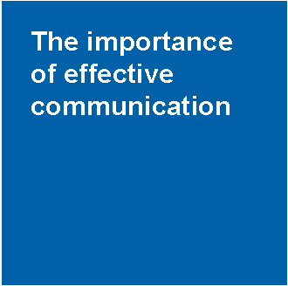
6Cs

Communication
Good communication develops your knowledge and understanding about individuals and the part played by other workers so that the best care and support possible can be provided. It helps build working relationships where each person's views are valued and taken into account.

Communication is an essential part of a caring relationship and helps to encourage trusting relationships with other workers and families as well as the individuals you
care for.

Types of communication

Talking is often seen as the most common method or type of communication but most communication is silent. Gestures, tone of voice, grins, grimaces, shrugs, nods, moving away or closer, crossing arms and legs all tell us far more than words. Learning to take account ofthese reactions is all part of developing your communication skills to achieve the best outcomes for individuals. Communication can be harder when we can't see these signs like when we use the phone, texts or email.

Individuals will have ways of communicating that work best for them. Some of the different types of communication are:

• Verbal communication - Differences in how you speak, including the tone, pitch and volume of your voice could change how your messages are taken in. Try
to avoid using jargon or abbreviations and complicated words and terminology. Make sure you always speak in a respectful way, adjusting your speech to suit the individual.
• Sign language - This is a recognised language throughout the world. British Sign Language (BSL) is used by individuals in this country and there are variations of sign language in different regions.
• Makaton - This is a form of language that uses a large collection of signs and symbols. It is often used with those who have learning and physical disabilities, or hearing impairment.
• Braille - Is a code of raised dots that are ‘read’ using touch. For people who are visually impaired or who are blind, the system supports reading and writing.
• Body language – This is a type of nonverbal communication. There are many different aspects of body language, including gestures, facial expressions, eye contact, body positioning and body movements. Each of these will communicate information about an individual or a worker often without them realising it.
• Gestures – These are hand or arm movements that emphasise what is being said or used as an alternative to speaking.
• Facial expressions – These support what is being said by showing reactions
or feelings. They can give you valuable clues that you can use to check out their feelings.
• Eye contact - Maintaining good eye contact is an important way for a worker to show that they are engaged and listening.
• Position - The way that we stand, sit or hold our arms when we are talking will provide others with clues about our feelings, attitude and emotions.
• Written communication - This method is used to send messages, keep records, or provide evidence.

Communication with other workers and individuals

Workers will develop many different relationships. Some will be formal and others more informal. Successful two-way communication is crucial. A relationship based on trust and understanding from the beginning will provide the basis for good care and support whether short of long-term.

Poor communication can quickly lead to confusion and distress. The process of exchanging information through communication is not always straightforward. If the information shared is inaccurate or misleading, mistakes can be made which can result in poor care.

Formal
Formal communication is likely to be used in the working environment, between you
and other workers.
Informal
Informal communication is likely to be used with friends and family, using familiar
words or slang.You should always use the communication method that is appropriate for the person and situation.

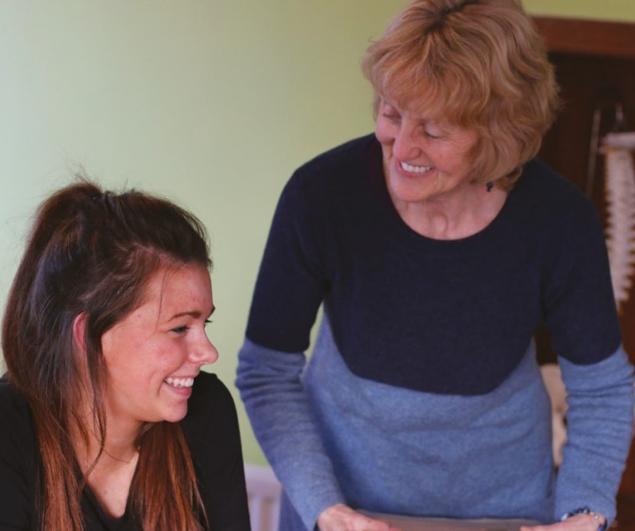
You should watch for clues from any individual that come from unspoken messages. These non- verbal ways of communicating come from body language, position, facial expressions or gestures. For example, when asking someone if they are
in pain, they may say ‘no’ but a wrinkled brow, uncomfortable facial expression or body movement may say otherwise. As an observant worker you will be able to notice when an individual is becoming confused, angry, upset, stressed or anxious without them telling you. You can then take action to help stop this from happening or help them express their feelings in the best way for them.

By noticing an individual’s reactions you can ask yourself the following questions:

• Do I need to change the type of communication I am using to help the individual understand?
• Do I need to be aware of how the conversation is affecting them?
• Is there something that the individual is not communicating to me that may help?

Recognising the unspoken messages can help you to ask good questions and develop supportive relationships. It improves trust as the individual can see that you are interested in them and trying to understand and meet their needs.

Communication and language needs, wishes and preferences

Individuals will have a range of different needs and preferences. Their unique communication needs will differ depending on their ability, disability, illness or condition.
To find out what an individual’s needs are you have to connect with them. If you can’t do it by talking you need to use other methods of communication to help them get information across to you in a way that works best for them. Another good source of information
would be the individual’s family, friends or carer. They will have experience of which communication methods work best.

Different methods of communication

Touch is used to communicate with people who are deaf and visually impaired. Workers sign information onto the individual’s hands as a way of passing on information.

For those whose communication skills may be limited, technological aids can be used. Hearing aids, hearing loops, text phones, text messaging on mobile phones and magnifiers are all forms of technological communication devices.

Some individuals may use word or symbol boards to support their speech and the listener will be able to associate the picture or word with the verbal communication in order to be able to understand what is being said.

Others may use speech synthesisers, which replace speech either by producing a visual display of written text or by producing synthesised speech that expresses the information verbally. Voice recognition software can be purchased for any computer to translate speech to written text.

When using communication aids always check that they function properly, that they are clean and in good working order. Should you have any worries about communication aids or technology not working properly, or being unclean, report this to a senior member of staff or the individual’s carer or family member.

Barriers to effective communication

A barrier is anything that will get in the way of communication. There are a wide range of barriers including:

Attitude - When a worker is abrupt due to time limits, not having enough resources or their mood, the person they are speaking to may feel intimidated or frustrated and not want to communicate.
Limited use of technology - When the technological aids known to be the best way for someone to communicate are not available.
Body positioning - Sitting too close could be intimidating and would make an individual feel uncomfortable. Sitting too far away could show lack of interest or concern.
Emotions - When someone is depressed, angry or upset their emotions may affect their ability to think and communicate in a sensible way.
Physical - When someone has physical conditions that create communication difficulties, for example, being breathless, not having any teeth or being in pain.
Not enough time - Not giving individuals time to say what they want to may make them feel rushed and reluctant to express their true wishes.
Poor or negative body language - Crossed arms or legs, poor facial expressions, poor body positioning, constant fidgeting or looking at a watch or mobile phone can all make someone less likely to communicate.
Lack of privacy - Think carefully about where and when private and confidential conversations should take place.
Stereotyping - Generalisations about a group of people that are wrong and misleading. An example would be that ‘all older people are hard of hearing’.
Other barriers could include sensory impairments, culture, language, noise, lighting or substance misuse.

Reducing barriers to communication

As a worker you should do what you can to reduce any barriers to communication. The most effective way to make sure that you are meeting someone’s communication needs and providing person centred care is to know as much as possible as you can about them.

A communication passport might be used by some which provides vital information about needs, wishes and preferences. These pull together the information into a format that is easy to read, often with pictures and photographs. Putting something together with an individual can be another good way of getting to know them well and understanding their needs. Your organisation might have a suggested format but at a simple level you can put one together with the individual to suit them.

It is important to get regular feedback about your communication style and methods from the people you provide care and support to so that you can continue to improve how you communicate. You could also increase your awareness of different communication needs and methods through taking up learning opportunities. Experience will help you to develop a variety of new methods of communication and selecting the best one in each situation. Be creative. Open body language and a positive, non-judgemental attitude will further help
reduce barriers. Your communication skills should be seen as a toolbox, using the right tool for the right job and choosing a different tool if one doesn’t work well.

Checking understanding

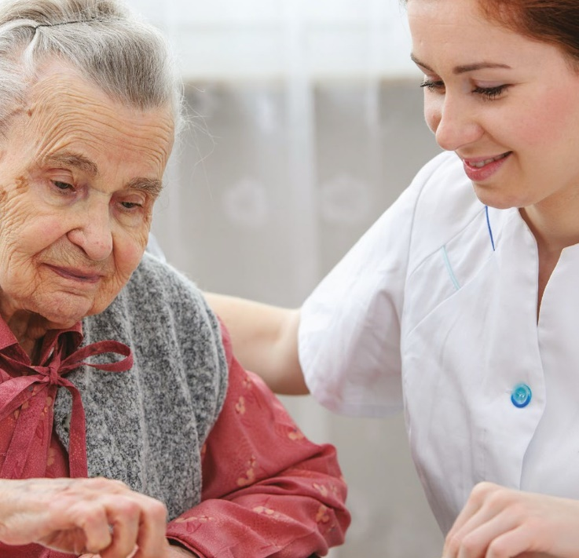
Checking that communication has been understood is an essential part of the process. A vital skill that checks understanding is summarising. A summary should bring together the main points of an exchange of information. This will allow the individual to correct you if necessary. This can help you to check that you have correctly understood. Questions are another way of checking whether a message has been received. Make sure you ask questions in a way that the individual has to provide a detailed response (open questions), rather than asking questions which only require a ‘yes’ or ‘no’ (closed questions). For example:
‘What do you like to do in your spare time?’. However, closed questions can be useful in some situations.

Summarise
This means to think about the main points of the conversation or communication and
shorten or simplify them in order to repeat them back to the individual. This will help to check your and their understanding.

Additional information and support

Information and support can be found from specialist charities and associations. Websites can provide material on forums, services or groups in the local area that you could attend or use to find out more. In addition, some local charities offer specific human aids such as befrienders, advocates or mentors. A befriender could support an individual in overcoming emotional difficulties that are a barrier to their communication. An advocate could communicate on an individual’s behalf if their skills are very limited. A number of additional key experts available to support individuals with their communication needs include
speech and language therapists, interpreters, translators, and clinical psychologists or counsellors. Further learning can come from other workers, your manager and a wide range of courses and qualifications.

Confidentiality

Confidentiality is an essential principle in health and social care and forms the basis of all ways of working and codes of practice. The basis of a good working relationship is trust. This is dependent on the individual being confident that personal information about them is treated confidentially. Information about someone must only be shared with others involved in their care and support on a ‘need-to-know’ basis. Any information should not usually
be disclosed without the person’s informed consent. The circumstances when information must be shared even if the individual does not give consent are listed later in this section.

Informed consent
To give informed consent the individual must be provided with all of the necessary
information in order to make a considered decision.

An individual’s right to confidentiality also means that a person’s notes or details must always be stored in a locked cupboard and not be left where they can be seen by unauthorised people. Computers or mobile devices such as electronic tablets need to be protected by a password and firewall. When talking about an individual you must ensure no others can overhear you.

It is essential that you abide by the principles of the:

Data Protection Act 1998 - This Act is for any public service provider.It says that any person has the right to confidentiality, to know which information is collected and that this data is up-to-date. Data should not be held for longer than necessary and everyone has the right to refuse to give information.
www.gov.uk/data-protection/the-data-protection-act

Human Rights Act 1998 – This Act determines a number of basic rights for any citizen of the UK. The important one in this context is the right to respect for private and family life, home and correspondence.
www.legislation.gov.uk/ukpga/1998/42/contents

Whenever possible, individuals should provide their consent for the transfer of information. However, this may not always be possible and there will be occasions when information normally considered confidential needs to be shared. Examples of occasions when confidentiality may have to be broken are:

• A person is likely to harm themselves
• A person has been, or is likely to be, involved in a serious crime
• A person is likely to harm others
• Your safety is placed at risk
• A child or vulnerable adult has suffered, or is at risk of suffering, significant harm.

There will be times when you face dilemmas about confidentiality, not knowing what to do or if you should speak to anyone about the information you have. At these times it
is important to speak with your manager and follow the agreed ways of working. If your manager is not available, a senior member of staff or other worker should be able to help.

Communication in practice

Communication may take place face-to-face, by telephone or text, by email, internet or social networks, by written reports or letters. Whether you are communicating face-to-
face, on the telephone or in written form, always be respectful, try to match your method of communication to the individual’s needs and be aware of confidentiality.

The CARE CERTIFICATE

Communication
(In General Practice)

• What do you know now?

Standard

THE CARE CERTIFICATE WORKBOOK

Activity 6.1a

Choose five different types of communication and describe how and when they might be used:

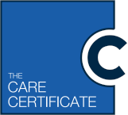
Communication

Describe - to describe means to create a picture with words but not simply writing
a list of bullet points.

Type | How and when it could be used
1.
2.
3.
4.
5.

Activity 6.1b

Use examples from your own workplace to describe how good and poor communication could affect
relationships at work:

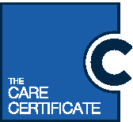

Describe - to describe means to create a picture with words but not simply writing
a list of bullet points.

1.Examples of good communication affecting a work relationship:

2.Examples of poor communication affecting a work relationship:

Activity 6.1c

Imagine you are talking to an individual about a new diagnosis they have just received. During the conversation, which starts very relaxed, you notice that the person starts getting fidgety and avoiding eye contact. Their
body language changes, they turn sideways on their chair so they no longer face you.

1. Why is it important that you notice the changes in the other person’s reactions?

2.Why is it important that you respond to the changes in the other person’s reactions?

Activity 6.2a

Part i) Use the spider diagram to list four ways that can help you to establish an individual’s language needs, wishes and preferences:

List: to list means to write in bullet points or provide short answers that are straight to the point.

Ways that can help me to establish language
needs, wishes &
preferences

Activity 6.2a

Part ii) Describe how each of the above can help you to establish an individual’s communication and language needs, wishes and preferences:

Describe: to describe means to create
a picture with words but not simply writing a list of bullet points. Details like why and how.

1

2

3

4

Activity 6.2b

Think of the different communication needs, wishes and preferences that individuals may have. Complete
the diagram below to list at least six different styles or methods of communication that could help you when communicating with individuals. An example has been provided for you:

List: to list means to write in bullet points or provide short answers that are straight to the point.

Touch

Communication styles and methods that help to meet needs, wishes and preferences

Activity 6.3a & b

Complete the table below to make a list of potential barriers to effective communication and describe ways to reduce the barrier. An example has been provided for you:

Describe: to describe means to create
a picture with words but not simply writing a list of bullet points. Details like why and how.

Barrier to communication | How it can be reduced
1. Substance misuse | If an individual’s behaviour is affected because of misuse of substances, I need to think carefully about how I will use my communication skills to make sure the individual  is supported. If they are frustrated and angry I will need to use a calming tone of voice and relaxed body language but maintain a safe distance.
2.
3.
4.
5.

Activity 6.3c

During any conversation or discussion, you would like to know that you have got your point across to the other person or people, and that they know or understand what you mean. How could you check
to make sure that the other person understands what you are saying?

Activity 6.3d

Think of an individual or group of individuals in your workplace that you might struggle to communicate with. Make sure you respect confidentiality by not using their name. Who could help you with information, support or services to communicate more effectively? How could they help?

The example from my place of work I have chosen is:

I could find information and support or services from:

They could help me to:

Activity 6.4a

In your own words, describe the meaning of confidentiality in relation
to your job role. You might
use your contract or job description to help you:

Describe: to describe means to create
a picture with words but not simply writing a list of bullet points details like why and
how.

In my job role as a Health Care Support worker in General Practice confidentiality means:

Activity 6.4b

Below are scenarios in which confidentiality must be respected. List the action you will take to ensure confidentiality is not broken.

.

List: to list means to write in bullet points or provide short answers that are straight to the point.

Scenario | Action to protect confidentiality
An individual has a blood test. All of the specimens you collect during a morning remain in your room until the end of the session. The blood form has the name of the patient and his condition written on the front.
You answer a telephone in reception and a lady enquires if Mr. Jones, one of your patients, has attended the surgery that morning.

One of your colleagues calls you over to read what the GP has just written in the notes of a patient. There is no obvious reason why this colleague should be reading these notes.
A patient asks you for her prescription to take to the chemist, and enquires if there is anything for her 16 year old daughter at the same time.

Activity 6.4c

At times you may come across situations where you need to share confidential information, even if the individual doesn’t want you to. Give three
examples of situations that might happen in your workplace where information might need to be passed on to other key people:

Example 1: Example 2: Example 3:

Activity 6.4d

Imagine one of the situations you have given above happens whilst you are on duty. Who could you ask for advice and support about confidentiality? How would they be able to help you?

People I could ask: | They could help me with advice and support because:

Care Certificate progress log, mapping and sign-off document

Standard Number: 6 Standard Title: Communication

Document guidance
This document provides an overview of the outcomes and assessment criteria for Standard 6: Communication. It identifies the criteria within the Standard that should have been achieved upon successful completion of the underpinning knowledge within the Care Certificate workbook. Employees must demonstrate their competence in practice in order to fully achieve this Standard of the Care Certificate.

This progress log and sign-off document should be completed jointly by the employee and the manager/supervisor/assessor to confirm that all outcomes and criteria have been achieved in practice in the work setting. Supplementary evidence can be attached to demonstrate achievement and it is suggested to do so as good practice.

This document also provides an outline of the suggested mapping of outcomes and criteria within Standard 6: Communication of the Care Certificate to the recommended Qualifications and Credit Framework (QCF) unit, the National Minimum Training Standards for Healthcare Support Workers and Adult Social Care Workers in England and the Common Induction Standards. This document does not necessarily indicate direct mapping of criteria and therefore assessors and/
or managers should ensure they follow the guidance below. Please note that when the term assessor is used throughout this document this could be the manager, supervisor or assessor and will be decided by the employing organisation.

This document should always be used in conjunction with the guidance provided in the Care Certificate Framework Technical Document.

Guidance for assessors
Assessors must ensure that the learner has produced evidence for each assessment criterion that is valid, authentic, reliable, current and sufficient. Therefore assessors must not assume that if the mapping document indicates a criterion could have already been achieved, the mapped criteria within the QCF unit should automatically be awarded. Learners and assessors are responsible for ensuring that the outcomes and criteria within the QCF unit and standards below have been achieved to the required standard. For reference, within the column that refers to coverage of the relevant QCF unit, a P indicates that the Care Certificate criteria provides partial coverage of the relevant criteria within the QCF unit, whereas an F indicates full coverage.

The Assessment method used column is included to allow assessors to provide evidence of the type of assessment method that has been used to assess the Care Certificate criteria. This is likely to be noted as the Care Certificate Workbook, however if further evidence is also provided this could include professional discussion, observation, question and answer, e-learning, witness testimony etc. This column can also be completed to evidence competency using these example assessment methods.

The Evidence location column is included to provide a clear signpost to where the learner’s evidence can be found. This may be within a portfolio of evidence, a continued professional development (CPD) file or electronically via e-learning or e-portfolio

Unit number | Unit title | Level | Credit
F/601/5465 | Introduction to communication in health, social care or children’s and young people’s place of work | 2 | 3
J/601/1434 | Promote communication in health, social care or children’s and young people’s place of work | 3 | 3

Care Certificate  Standard 6  Outcome | Care Certificate  Standard 6 Criteria | Knowledge/ Competence | Question within workbook | QCF unit  F/601/5465  Introduction to communication in health, social care or children’s and young people’s place of work  P = Partial  F = Full | QCF unit  J/601/1434  Promote communication in health, social care or children’s and young people’s place of work  P = Partial  F = Full | National  Minimum Training  Standards  Standard 3: Effective communication | Common Induction Standards  Standard 3: Communicate effectively | Assess- ment method used | Evidence location | Sign- off initials | Date
6.1 Understand the importance of effective communication at work | 6.1a Describe the different ways that people communicate | K | 6.1a | AC1.1 – P | AC1.1 – P | 3.1.1 | S3 – 1.1
 | 6.1b Describe how communication affects relationships at work | K | 6.1b | AC1.2 – P | AC1.2 – P | 3.1.2 | S3 – 1.2
 | 6.1c Describe why it is important to observe and be receptive to an individual’s reactions when communicating with them | K | 6.1c | AC1.3 – P AC3.3 – P |  | 3.1.3 | S3 – 1.3
6.2 Understand how to meet the communication and language needs, wishes and preferences of individuals | 6.2a Describe how to establish an individual’s communication and language  needs, wishes and preferences | K | 6.2a part i  6.2a part ii | AC2.1 – P | AC2.1 – P | 3.2.1 | S3 – 2.1
 | 6.2b List a range of communication methods and styles that could help  meet an individual’s communication needs, wishes and preferences | K | 6.2b | AC2.2 – P | AC2.3 – P | 3.2.2 | S3 – 2.2

6.3 Understand how to promote effective communication | 6.3a List barriers to effective communication | K | 6.3a and b | AC3.1 – F | AC3.2 – F | 3.1.1 | S3 – 3.1
 | 6.3b Describe ways to reduce barriers to effective communication | K | 6.3a and b | AC3.2 – P | AC3.3 – P | 3.3.2 | S3 – 3.2
 | 6.3c Describe how to check whether they (the HCSW/ ASCW) have been understood | K | 6.3c | AC3.3 – P | AC3.4 – P | 3.3.3 | S3 – 3.3
 | 6.3d Describe where to find information and support or services, to help them communicate more effectively | K | 6.3d | AC3.4 – F | AC3.5 – P | 3.3.4 | S3 – 3.4
6.4 Understand the principles and practices relating to confidentiality | 6.4a Describe  what confidentiality means in relation to their role | K | 6.4a | AC4.1 – P AX4.3 – P | AC4.1 – P | 3.4.1 | S3 – 4.1
 | 6.4b List any legislation and agreed ways of working to maintain confidentiality  in day-to-day communication | K | 6.4b | AC4.4 – P | AC4.2 – P | 3.4.2 | S3 – 4.1  S3 – 4.2
 | 6.4c Describe situations where information,  normally considered to be confidential, might need to be passed on | K | 6.4c | AC4.3 – F | AC4.3 – P | 3.4.3 | S3 – 4.3
 | 6.4d Describe who they should ask for advice and support about confidentiality | K | 6.4d | AC4.4 – P |  | 3.4.4 | S3 – 4.4

6.5 Use appropriate verbal and non-verbal communication | 6.5a Demonstrate the use of appropriate verbal and non-verbal communication:  Verbal:  • Tone  • Volume  Non-verbal:  • Position/ proximity  • Eye contact  • Body language  • Touch  • Signs  • Symbols and pictures  • Writing  • Objects of reference  • Human and technical aids. Communication may take place:  • Face-to-face  • By telephone or text  • By email, internet or social networks  • By written reports or letters. | C |  | AC2.2 – P | AC2.3 – P AC2.4 – P AC3.3 – P AC3.4 – P | 3.2.1  3.2.2  3.3.1  3.3.2  3.3.3 | S3 – 2.2  S3 – 3.1  S3 – 3.2  S3 – 3.3
6.6 Support the use of appropriate communication  aids/ technologies | 6.6a Ensure that any communication aids/ technologies  are:  • Clean  • Work properly  • In good repair. | C |  | AC3.2 – P | AC3.3 – P | 3.3.2 | S3 – 3.2

 | 6.6b Report any concerns about the communication aid/ technology to the appropriate person. This could include:  • Senior member of staff  • Carer  • Family member. | C |  | AC3.4 – P | AC3.5 – P | 3.3.4 | S3 – 3.4

Declaration of completion
I confirm that the evidence provided by the employee meets the full requirements for Standard 6: Communication.

Employee signature: Name of assessor*: Assessor* signature:
Completion date:

* The Assessor can be your Manager, Supervisor or someone else authorised by your employing organisation. This individual provides confirmation that all learning
outcomes and assessment criteria for the Care Certificate standard identified above have been completed and signed off by an authorising person.

