NHS Confederation survey to gather views on the resource:

Combatting racial discrimination against minority ethnic nurses, midwives and nursing associates: Resource for nursing and midwifery professionals registered with the Nursing and Midwifery Council.

Introduction
In November 2022 the resource Combatting racial discrimination against ethnic minority nurses, midwives, and nursing associates was published by NHS England in partnership with the Nursing and Midwifery Council and NHS Confederation.
The resource is for all nursing and midwifery professionals registered with the Nursing and Midwifery Council working in the NHS, and supports all nurses, midwives and nursing associates across health and care.
As registered professionals, nurses, midwives and nursing associates all have responsibility under the NMC Code to challenge discriminatory behaviour, creating an environment where people are treated as individuals and with dignity and respect.
The resource can help nurses, midwives and nursing associates to act according to best professional practice if they experience racism, witness racism and in leading anti-racism. The resource also outlines the expected behaviours from NHS organisations and leaders.
As part of the continuing development of this resource, NHS Confederation are gathering views via a short usability survey. The feedback will provide insights on how the resource is used and identify where improvements can be made. The survey closes on 1 September 2023.
About the survey
The usability survey aims to help us understand if the resource is helpful to nursing and midwifery professionals working in the NHS in discharging their professional duty in challenging racism. It should take no more than 10 minutes to complete the survey.
Group discussions
In addition to the survey, there is also an opportunity to gather insights on what has/hasn’t worked well and why, in small group discussions.
Audience
The survey is open to anyone that has used the resource.
Bulletin article 1 – short
Take part in this NHS Confederation short survey gathering views on the Combatting racial discrimination against ethnic minority nurses, midwives, and nursing associates resource published last year. The feedback gathered will provide insights on how the resource is being used and identify where improvements can be made.

Bulletin article 2 – long
Take part in this NHS Confederation short survey gathering views on the Combatting racial discrimination against ethnic minority nurses, midwives, and nursing associates resource, published by NHS England, the Nursing and Midwifery Council and NHS Confederation. The resource aims to help nursing and midwifery professionals working in the NHS combat racism and secure their own and their colleagues’ wellbeing and psychological safety.
If you have used the resource please spare 10 minutes to share your views. The feedback gathered will provide insights on how the resource is being used and identify where improvements can be made.
Alternatively, share your views via one of our group discussions. To take part please email bln@nhsconfed.org.
Please help promote this survey by sharing with your colleagues and teams.

Tweet 1 – survey

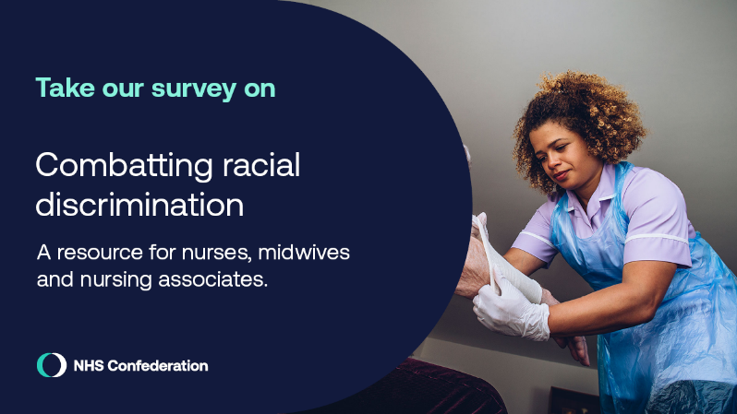
Have you used the ‘Combatting racial discrimination against ethnic minority nurses, midwives, and nursing associates resource’?

Take this @NHSConfed short survey to help us make improvements. @NHSEngland #teamCNO @NMCNews

https://forms.office.com/e/sRUyULU7qB

Tweet 2 – group discussion

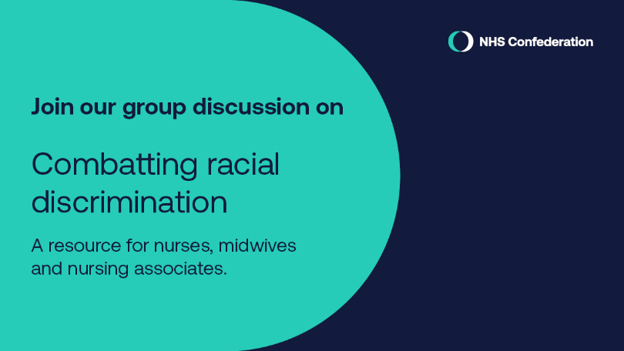

Have you used the ‘Combatting racial discrimination against ethnic minority nurses, midwives, and nursing associates resource’? @NHSEngland #teamCNO @NMCNews @NHSConfed

Take part in a discussion and help us understand where improvements can be made. Email bln@nhsconfed.org
https://forms.office.com/e/sRUyULU7qB

Powerpoint slide for use in meetings and events

