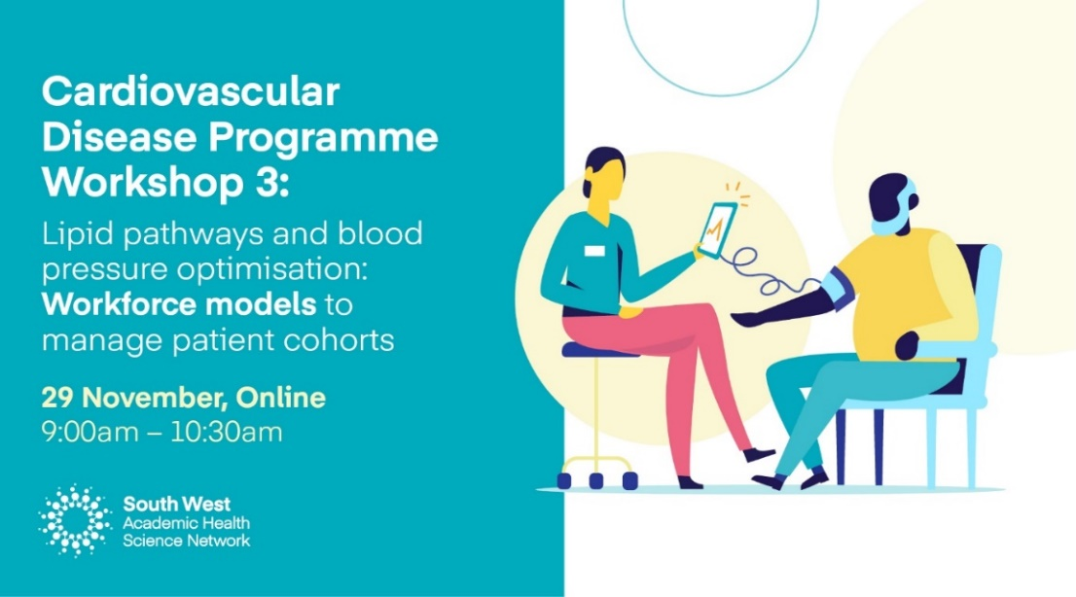
Read more & sign up here

A reminder that we are hosting a Cardiovascular Disease (CVD) Programme workshop on 29 November 9-10:30am, which will focus on new workforce models for implementing the lipid and blood pressure optimisation pathways effectively. If you haven't already, sign-up here.

We are delighted to be joined by the following experienced and inspirational speakers who will share the latest approaches in workforce transformation and illustrate them with real-world successful examples in practice.
- Aiysha Saleemi, Pharmacist Advisor, UCL Partners, will show us how to optimise your multidisciplinary workforce to support patients with CVD and the available support on offer.
- Judith Magowan, Practice Nurse and CVD Lead, Okehampton Medical Centre, Devon will be sharing the centre's inspirational case study of how they improved health outcomes of patients by adapting, training and developing their staff to efficiently deliver patient care and prevent CVD.
- Professor Ahmet Fuat, GPSI in Cardiology and Honorary Professor of Primary Care Cardiology at Durham University will present an overview of his experience on the ground and the benefits of innovative workforce models that can be adapted to lipid pathways.
How to prepare:
Bring your questions and top tips: What do you want to know? What has worked already? What are your challenges? What support do you need?

Key resources
- UCLPartners frameworks: Proactive care frameworks
- Tackling Cholesterol Together links: Tackling Cholesterol Together - HEART UK
- CVD Resources from UCLPartners
- South West AHSN Cardiovascular Disease Programme webpage here.
Missed the first two CVD workshops? Catch up at the links below.
Workshop 1: Lipid pathway: Search and stratification tools. Watch here.
Workshop 2: Blood pressure optimisation: Tools and support in theory and practice. Watch here.

For more information please contact South West AHSN CVD Programme Managers Harriet.Matthews@swahsn.com or Marie-Joelle.West@swahsn.com

