South West General Practice Quality Network
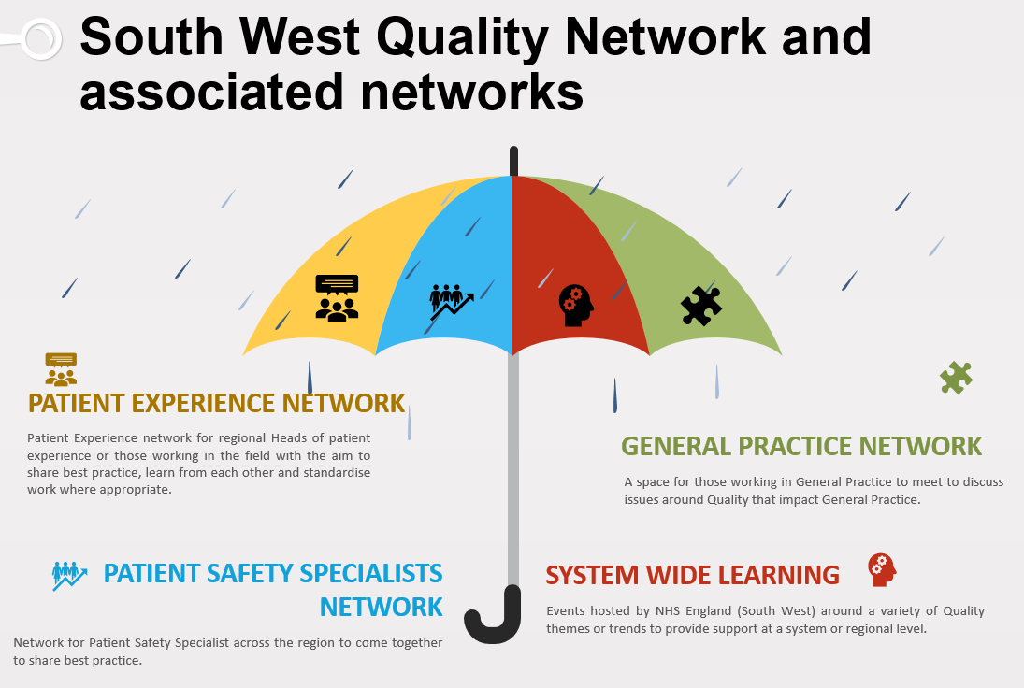
What is the purpose of the meeting?
You are invited to help set up an informal network space for individuals working within and with General Practice staff to come together and discuss quality topics relevant to General Practice. The first meeting will include an overview of the NHS Patient Safety Strategy from a General Practice perspective.

Who is the meeting for?
All those that work in and with General Practice staff,
Including practice staff, PCN managers, ICB Patient Safety leads etc.

When is the meeting?
The inaugural meeting is
Wednesday 12 October 12 Midday – 1:30pm

How do I receive an invite?
Register for the network meeting england.swqualityhub@nhs.net

