Mental Health First Aid – free training available!

Fully funded Mental Health First Aid training

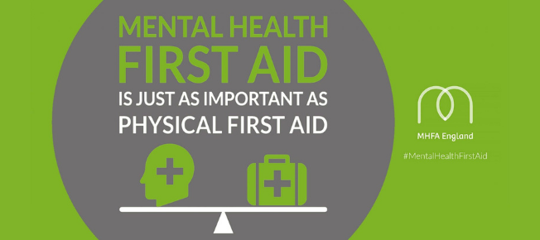
Somerset County Council has received funding from the European Social Fund (ESF) to offer free training opportunities to the workforce. This means that training such as Mental Health First Aid is available and free for Council and NHS employees to enrol.

What is Mental Health First Aid (MHFA) training?
The two-day training course will be held face-to-face in a number of locations across Somerset, and you must also attend a one-hour, online, pre-course workshop before the training is delivered.
The MHFA qualification will teach you how to spot early signs and symptoms of common mental health problems, such as anxiety, depression and schizophrenia, for example. The course will give you the knowledge and tools to be able to deliver Mental Health First Aid before professional, medical treatment is available.
Please note that as a qualified Mental Health First Aider, or someone who has undertaken a Mental Health First Aid course, you will not be able to diagnose or treat but you can identify symptoms of anxiety, depression, eating disorders, amongst other challenges, and encourage someone to seek professional help. These courses do not teach you to be a counsellor or therapist but will empower you to react and signpost when someone in mental distress may need professional help.
If you would like to become a Mental Health First Aider and are available for any of the course dates below, please click here to sign up.

Cohort 11 – Online Workshop 05/10/22 at 10am
MHFA 2 Day Delivery, 6th and 7th October – Bridgwater. 09:30 – 17:30
Cohort 12 – Online Workshop 18/10/22 @ 10am
MHFA 2 Day Delivery, 19th and 20th October – Taunton. 09:30 – 17:30
Cohort 13- Online Workshop 01/11/22 at 11am
MHFA 2 Day Delivery, 2nd and 3rd November – Yeovil. 09:30 – 17:30
Cohort 14 – Online Workshop 21/11/22 at 10am
MHFA 2 Day Delivery, 22nd and 23rd November – Shepton Mallet. 09:30 – 17:30
Cohort 15 – Online Workshop 06/12/22 at 10am
MHFA 2 Day Delivery, 7th and 8th December – Taunton. 09:30 – 17:30

More courses will be arranged once the ones above have been filled, so if you can’t attend any that are currently listed, please email Jess Davis at jdavis@somerset.gov.uk and she will add you to the waiting list.

