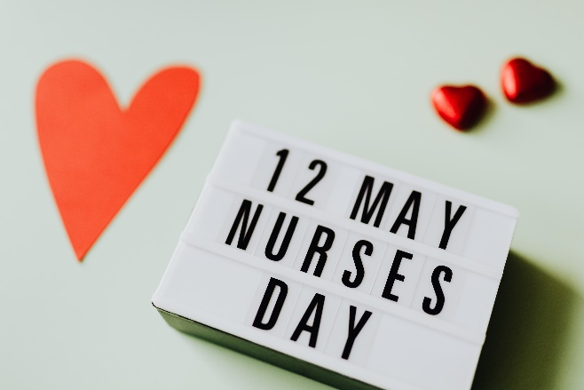
THE NHS SOUTH WEST REGION NURSING DIRECTORATE
CORDIALLY INVITES YOU TO A VIRTUAL EVENT CELEBRATING & SHOWCASING
THE DIVERSITY OF ROLES IN COMMUNITY NURSING
DATE: THURSDAY 12TH MAY 2022
TIME 2.30PM – 4PM
Formal thank you from
CHIEF NURSE SUE DOHENY
THIS EVENT IS OPEN TO ALL COMMUNITY NURSES IN SOUTH WEST REGION.
TO JOIN, PLEASE CLICK ON THE LINK BELOW:
Click here to join the meeting

NHS England and NHS Improvement

