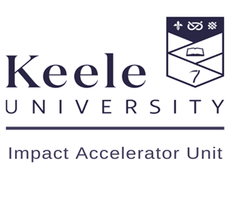
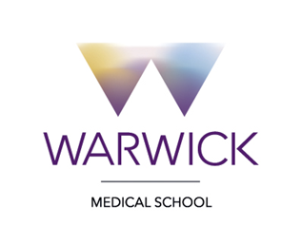

Developing Best Research in Primary Care and Community Nursing

A free, virtual conference for all student nurses, nurses and leaders of primary care and community organisations across the UK.

March 31 2022

Microsoft Teams

9:15 AM to 16:00 PM

Please register to attend via this link , by 28 March

Please note that you will receive a separate link to join the meeting 24-48 hours before the conference, so look out for that in your inbox.

An exciting new virtual conference hosted by Dr. Andrew Finney, Senior Lecturer in Adult Nursing and Post-Doctoral Researcher (Keele University) and Eleanor Hoverd, HEE/NIHR Doctoral Fellow/ CRN West Midlands Primary Care Research Nurse (Warwick Medical School).

We will be listening to the journey’s of nurses working in primary care and community nursing share their own innovations and incredible research, including particpants from the CARE programme who will share population health improvement iniatives as part of the national programme across England. They will also be talking about their experiences of how their careers are developing within the sphere of research and innovation, discussing some of their challenges and successes.

