ICON training for champions
Infant crying is normal, and it will stop
Comfort methods can sometimes soothe the baby
It’s Ok to walk away if you have checked the baby is safe and the crying is getting to you. After a moment when you are feeling calm, go back and check and continue comfort methods
Never, ever shake or hurt a baby

The intended outcome is to raise awareness of the role played by everyone in making every contact and interaction with families count to embed SUDI and ICON prevention across Somerset. By generating supportive conversations that enable parents and carers to address coping with crying, learn about different comfort methods and what to do if their baby’s crying gets too much.

What is the course about?

ICON is an evidence-based prevention programme designed to tackle incidence of non-accidental injury and abusive head trauma. The training incorporates SUDI prevention and raises awareness of common risk factors, protective factors, and support for families.

Who is the training for?

ICON key messages and prevention agenda is relevant to all. The champion training is available to every Health, Social care, Early Years and Education organisations and settings, police service, fire service, specialist services and wider partners including all VCSE partners working with and supporting families during their maternity and parenting journey.

This training includes a cascade element, and we recommend that those attending be well positioned to raise the awareness of ICON, SUDI and the key messages including how to access and use the resources, in their organisation or setting.

Book on ICON Champion Training, follow the link to training available on Somerset Safeguarding Children Partnership training and events calendar | Event List : ICON - Training for Champions (event-booking.org.uk)  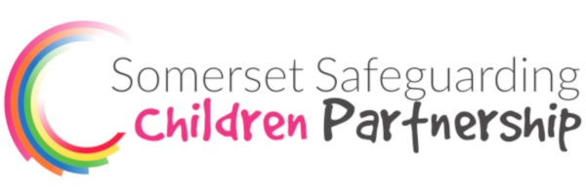
Example Resources | I am unshakable https://youtu.be/Q3mc0FhrNF8  Ellis’ story https://youtu.be/aqCbREcduMA (Viewer discretion advised)
Further Useful Information and Resource Website | Somerset Maternity Toolkit ICON section Somerset children & young people : Health & Wellbeing : Safety Coping With Crying (cypsomersethealth.org)  Resources for Practitioners Page on Somerset maternity toolkit Somerset children & young people : Health & Wellbeing : Icon Resources For Prctitioners (cypsomersethealth.org)

The ICON Programmes incorporates key messages within a series of touch point interventions throughout universal and secondary services for children and families. It also incorporates a simple 'safe sleep' message. ICON resources are there to support parent/carers understanding the need for coping with crying to help prevent injury. We recommend you share the ICON messages with everyone around you and see also DadPad and Safer Sleep.

