Our Ref: ...

Date ...

PRIVATE AND CONFIDENTIAL

Dear ...

This COPD Assessment Tool (CAT) is designed to assess your COPD control and if you need a ‘face to face’ yearly review. The information that you submit will be analysed along with your care records and if there are any areas of concern, a member of the Practice will be in touch with you.
However, if you feel that your COPD is poorly controlled, you may wish to make an appointment with the Nurse or Nurse Practitioner rather than completing a questionnaire.
If all is well we may make an appointment in a years time but please contact us if you feel your COPD is worse at any time.

If you do not complete or return the questionnaire a routine appointment will be sent automatically. So please respond accordingly or valuable appointments will be wasted.

Please also find enclosed your personal COPD action plan which you need to complete and keep in a safe place for future reference. If you need any help completing this, please let us know.

If you are taking regular inhalers you are then eligible for an annual flu vaccine. These are bookable from September to February each year. Contact the surgery between these dates to arrange an appointment.

Yours sincerely

A few online websites that you might find useful for further information:

- What is COPD: www.blf.org.uk/support-for-you/copd/what-is-copd
- How is COPD diagnosed: https://www.blf.org.uk/support-for-you/copd/diagnosis Treatments for COPD: www.blf.org.uk/support-for-you/copd/treatment
- How to manage a flare-up: www.blf.org.uk/support-for-you/copd/flare-ups
- Living with COPD -copd/living-with/ www.nhs.uk/conditions/chronic-obstructivepulmonary-disease-copd/living-with/
- Videos showing how to get the best out of your inhalers: www.asthma.org.uk/advice/inhaler-videos/
- Exercise ‘One You’ - www.nhs.uk/oneyou/for-your-body/move-more/
- Tips and suggestions for looking after your mental health – www.nhs.uk/oneyou/every-mind-matters
COPD Questionnaire
Full Name: |  |  |  | Date of Birth:
Phone Number: | Home: |  |  |  | Mobile:
EMIS Number: | Office use only |  | Height: |  |  | Weight:
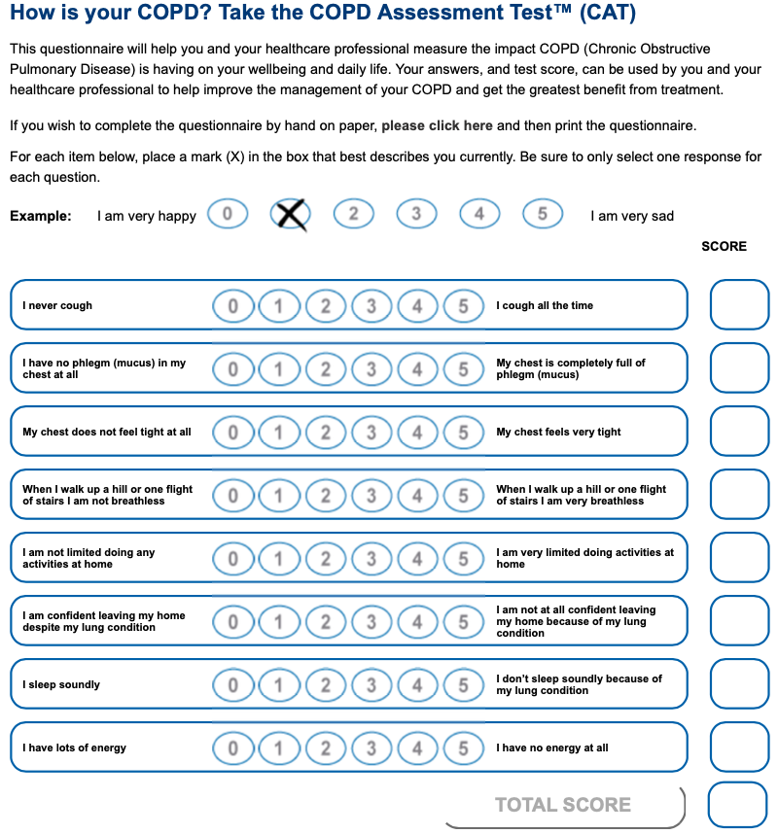

EXACERBATIONS:
- Number of COPD Exacerbations in the past year resulting in the use of steroids and/or antibiotics: ________

MRC SCORE:
- Please circle the number which best corresponds to your breathlessness:

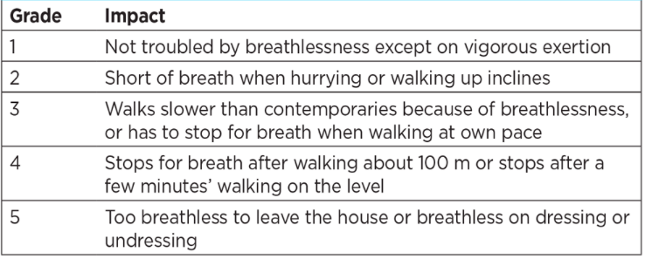

Are you confident you can use your inhaler correctly
YES |  | No |  | Need Help

SMOKING STATUS:

Do you smoke? Yes No

If Yes, how many cigarettes do you smoke per day ( ) OR per week ( )
OR How many cigars do you smoke per day ( ) OR per week ( )
OR How many ounces of tobacco per week ( )

If NO, please tick as appropriate - Never smoked Ex-smoker

How many did you smoke ( ) Date you stopped ( )
Have you been offered smoking cessation advice? Yes No
If you would like advice, help and support regarding stopping smoking please contact Smokefreelife Somerset on 01823 356222. Also most pharmacies will have a trained stop smoking advisor there to assist and advice.

Please provide any extra information that might help the team:

