Dear Colleagues

As you are  now  probably aware , there has been a surge in RSV and other respiratory illness in children . This is starting to filter its way into increased contact in both Primary and secondary care .

I am aware of the challenges that everyone is facing in managing this cohort of patients in a safe and reassuring manner . Many of the newer parents will be unfamiliar with managing unwell children and when to access help .

Enclosed is also some guidance for remote and in person assessment of children with age specific advice

**A clinical support tool to aid with remote assessment of cough and breathlessness in children <1 year age.**

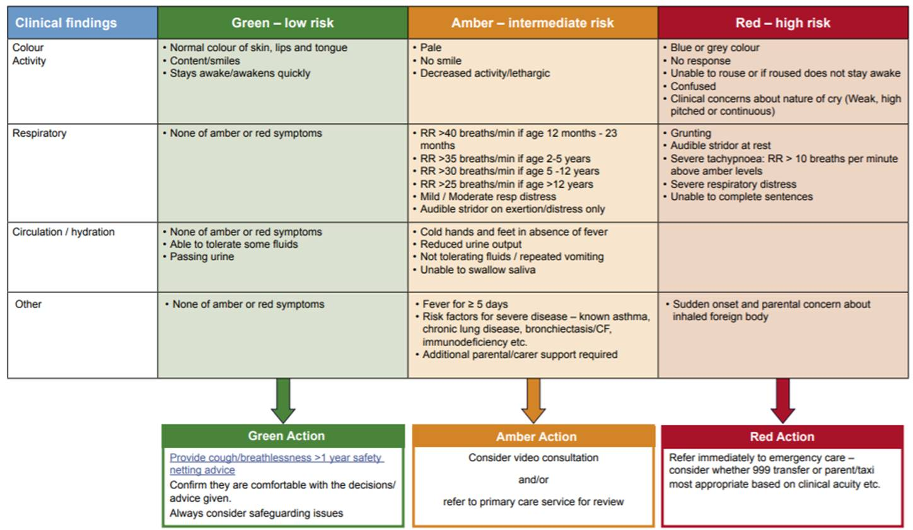

**A clinical support tool to aid with remote assessment of cough and breathlessness in children <1 year age.**

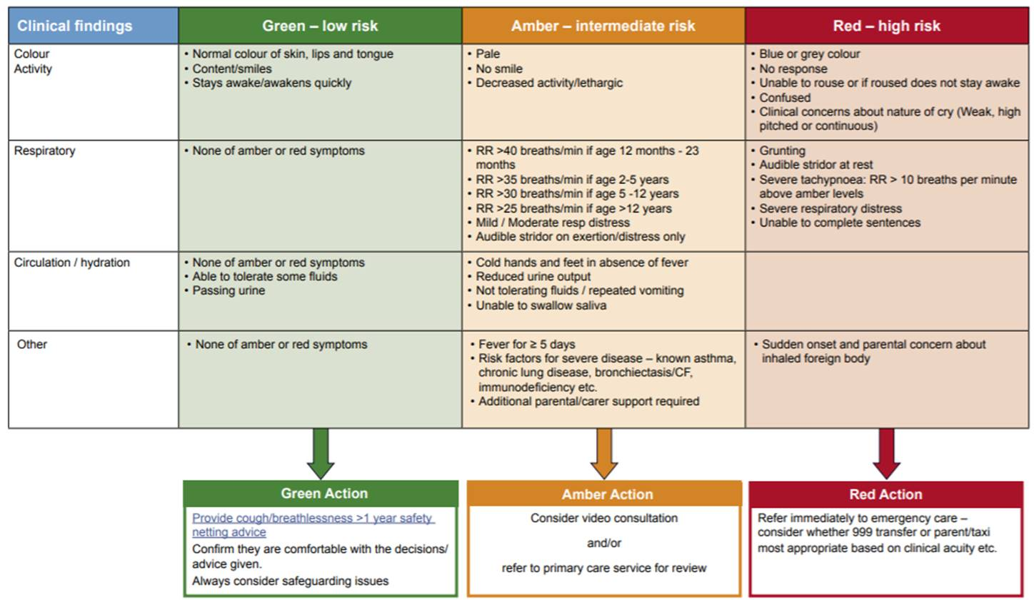

**Pathway for the assessment and management of suspected bronchiolitis in primary care and the community in babies < 1 year of age**

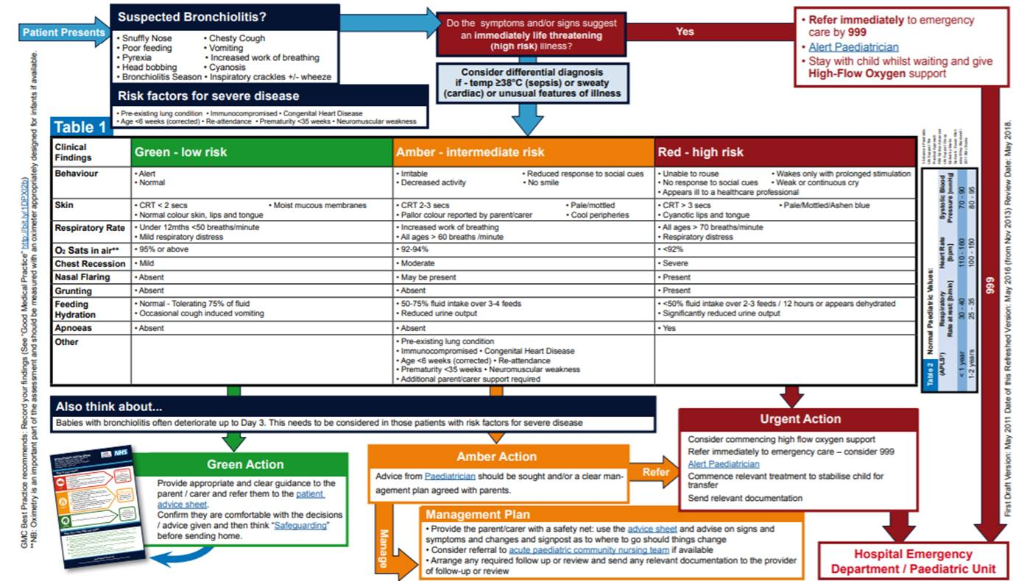

This will cause challenges as the symptoms are similar to COVID and so appropriate precautions will need to be taken .

However it is important to prioritise assessment of Children in Primary Care due to their clinical condition changing rapidly .

With this in mind I wonder if practices would consider sending Accurx messages to parents of under 3 year olds asking them to download the Handi App for reference and possibly attaching a Patient Information Leaflet . Hopefully better informed patients will help !

Find enclosed a search and a report to output NHS and EMIS number. DO NOT OPEN IT WITH WINDOWS! Download it to your PC. DO NOT OPEN IT (even if the Windows system prompts you – just close that prompt).

Go to the EMIS population reporting area and create a new folder, select “Import” from the top menu and go to where you downloaded the xml file on your computer. It can then be run/opened from there and all will be well. See if it matches what you would expect to see on your system. You can export the report into a CSV file and save it somewhere to feed into AccuRx. Obviously if you don’t want to do all that forward it on to someone who creates your searches and reports.

Link to batch messaging instructions – <https://support.accurx.com/en/articles/4890999-how-to-use-accurx-batch-messaging>

We are working with the Acute trusts to provide advice and guidance to support decision making in Primary Care and are looking at a range of other measures that could be implemented to help support care across Somerset during this challenging time

Dr Jeremy Imms

Associate Clinical Director Primary Care

​Somerset Clinical Commissioning Group | *Working together to improve health and wellbeing*   
​t: 01935 381962 (voicemail messages will reach me remotely) | e: [Jeremy.imms1@nhs.net](mailto:Jeremy.imms1@nhs.net)  
​Website:  [www.somersetccg.nhs.uk](http://www.somersetccg.nhs.uk/)

Twitter:  @somersetccg ​

Facebook:  @SomersetCCG