Cow’s Milk Protein Allergy Vignette
Dr Katie Pearson, ST5 Royal Devon & Exeter NHS Foundation Trust

The number of infants diagnosed with Cow’s Milk Protein Allergy (CMPA) has increased significantly over the past 10 years, with specialist formula currently costing the NHS £66million a year. The diagnosis can be challenging due to the non-specific symptoms and parental concerns. This vignette outlines the management of suspected CMPA.
Case: A 4 week old male baby, previously exclusively breastfed, who has started screaming and vomiting since being given formula top ups at night. Examination is normal and his weight is following the 25th centile.
Could this be CMPA? Vomiting and screaming are both normal baby behaviours, however they have developed/worsened since the addition of formula, therefore clinical suspicion is high enough to warrant a trial of a cow milk exclusion diet as per iMAP guidance:
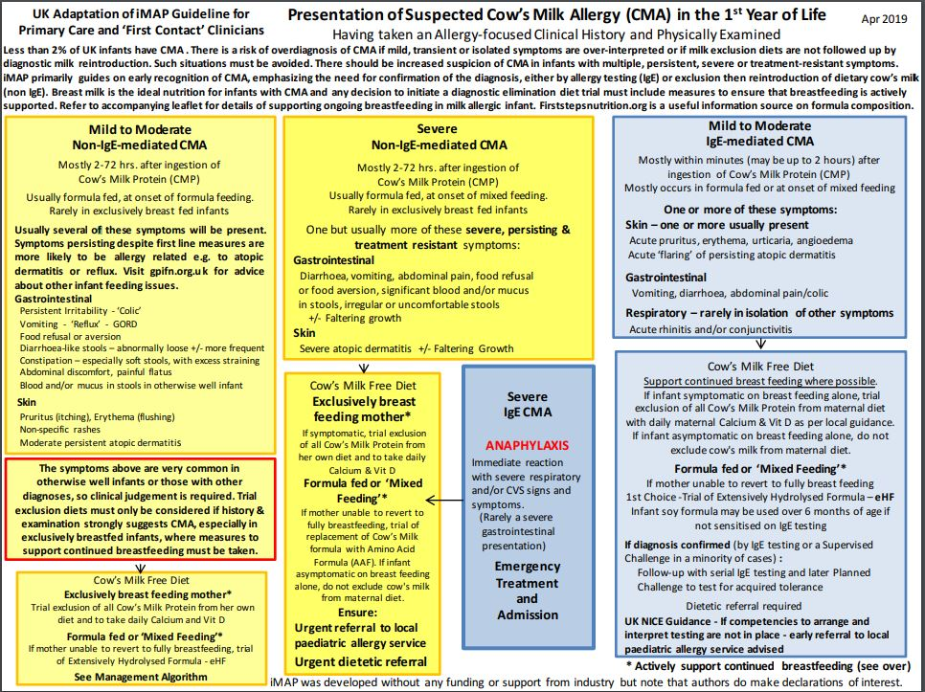
Should Mum stop breastfeeding? Breastfeeding should be actively encouraged and supported in accordance with World Health Organisation's guideline of 6 months exclusive breastfeeding. As the baby was asymptomatic during exclusive breastfeeding, and no evidence of severe reaction from history and examination, mum does NOT need to exclude cow’s milk protein from diet
Which formula? If switching back to exclusive breast feeding is not an option, the baby should be started on an extensively hydrolysed formula as he is suspected to have a mild-moderate non-IgE mediated reaction. SMA Althera is the first line as per joint formulary:
How long does he stay on an eHF? The exclusion trial should last for 2-4 weeks and then improvement is assessed. Diagnosis must be confirmed by the offer of reintroducing dairy. If CMPA is confirmed, tolerance can be tested after at least 6 months of exclusion.
When do I refer? All breastfeeding mums on diary-free diet should see paediatric dieticians and should be on adequate vitamin D and calcium supplementation.
If a baby is still symptomatic on an extensively hydrolysed formula please trial an amino acid formula and refer in to paediatric allergy. Babies with severe reactions require urgent referral to the local paediatric allergy service. Paediatric dietitians can also support dairy free weaning, some information sheets can be found here in the patient leaflet section.
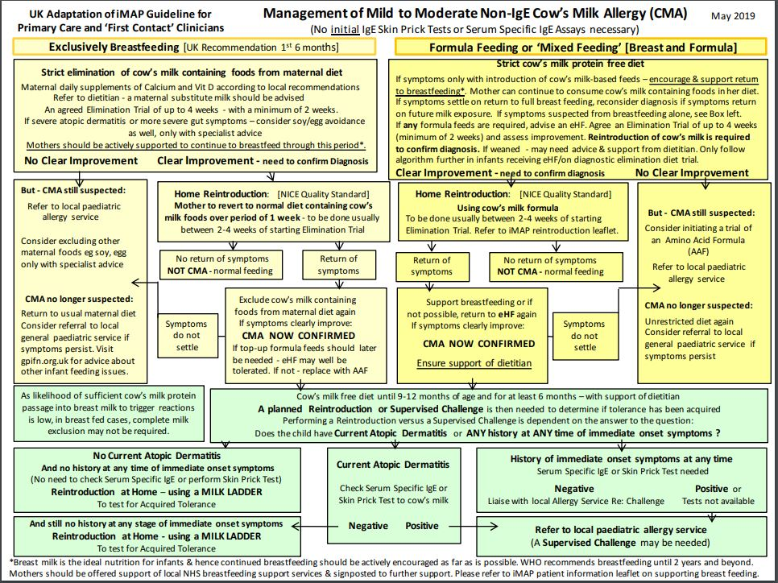
Additional parent and health care professional information can be found at the useful GP infant feeding network website here.

