Allergic Rhinitis
Dr Nicole Whalley GPVTS, Royal Devon and Exeter Hospital
Overview
Allergic rhinitis (AR) is common, affecting over 20% of people in the UK. It impacts significantly on quality of life; school performance and it is a risk factor for development, and poor control, of asthma. AR is diagnosed by history and examination.
AR is an IgE-mediated disorder of the nasal mucosa caused by exposure and sensitisation to airborne allergens resulting in inflammation.
This vignette is designed to refresh your memory on the steps to treatment of allergic rhino-conjunctivitis and when to escalate treatment and referral for allergy input.
Management Options (Table 1)
- Allergen avoidance
- Effective in certain seasonal AR, but difficult for some allergens
- Nasal saline douches or other non-pharmacological barrier methods.
- Minor decongestant benefits and improves clinical outcomes
- Antihistamines (AH)
- Second-generation antihistamines are long acting, non-sedating and without anti-cholinergic activity at therapeutic doses. Please do NOT prescribe first generation (e.g. chlorphenamine)
- Effective at reducing AR symptoms compared to placebo.
- Intranasal steroids (INS)
- Preferable to use INS with low bioavailability due to a better safety profile at recommended doses (e.g. Fluticasone furoate (Avamys), Mometasone furoate (Nasonex) and Fluticasone and Azelastine (Dymista))
- INS reduce all symptoms of rhinitis superior to AH or leukotriene receptor antagonists
- Leukotriene receptor antagonist (LTRA)
- Similar nasal symptom relief to that of AH but less efficacious as compared to INS
- Good add on therapy for patients who wheeze or cough on high pollen days (e.g. Montelukast)
- Immunotherapy
- Progressive administration of allergen preparation subcutaneously or sublingually to induce immunologic and clinical immune tolerance and long-term resolution of symptoms
- Can modify the disease course, causing symptom remission
- Reduces progression to asthma
- Requires secondary care involvement, available to select patient groups
Always avoid sedating antihistamines (e.g. chlorphenamine or hydroxyzine) and chronic use of decongestants in your patients due to unacceptable side effect profiles, especially when safer methods of treatment are available.
Please always check your patients intranasal spray technique
Need for Referral (Table 2)
- To allergy team if diagnostic uncertainty, persistent symptoms, not responding to treatment or for consideration of immunotherapy.
- To ENT if red flag symptoms including unilateral symptoms, blood-stained discharge, pain
Key Resources
BSACI guidelines
NICE Clinical Knowledge Summary: Rhinitis
World Allergy Organization Overview of Allergic Rhinitis
South West NHS Formulary

Authors:
Dr Nicole Whalley, ST1 Paediatric doctor,
Dr Siân Ludman, Paediatric allergy consultant, Royal Devon & Exeter NHS Foundation Trust

Appendices
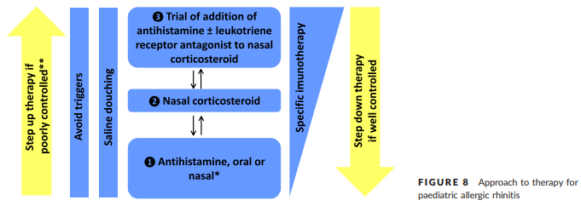
Table 1: Approach to therapy for paediatric allergic rhinitis reproduced from Scadding et al. 2007

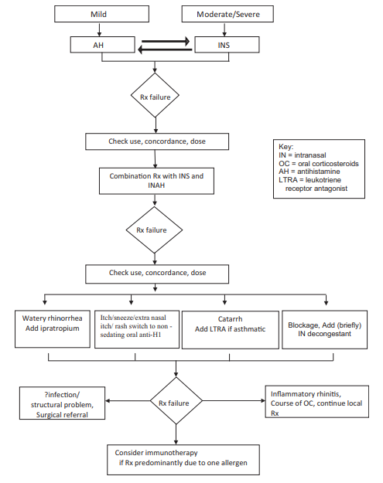
Table 2: Rhinitis treatment algorithm, reproduced from Scadding et al. 2007

