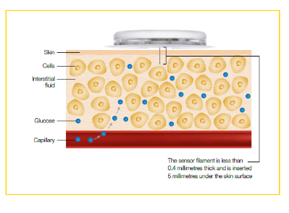**Freestyle Libre Flash Glucose Monitor**

**What is Flash Glucose Monitoring?**

Flash Glucose Monitoring enables monitoring of glucose without finger pricking. The patient applies a small sensor to the back of the upper arm. A sensor filament runs 5mm subcutaneously from the sensor and measures interstitial glucose.

Finger prick blood glucose readings and sensor glucose reading won't always match. There is a 5-10 minute delay in interstitial glucose response to changes in blood glucose, but generally glucose readings in interstitial fluid do reflect blood glucose levels.

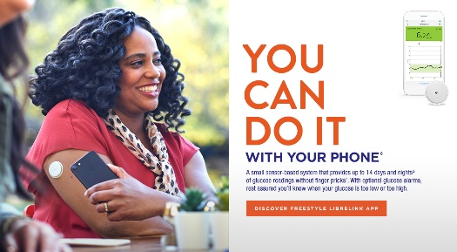

The sensor is scanned using a handset phone or mobile phone. As long as the sensor is scanned adequately, it automatically measures and continuously stores glucose readings day and night. In addition, the Freestyle Libre 2 has optional high and low sugar alarms.

**NHS England criteria for a Freestyle Libre:**

1. People with **Type 1 diabetes**

OR with **any form of diabetes on hemodialysis and on insulin treatment**

*who, in either of the above, are clinically indicated as requiring intensive monitoring >8 times daily, as demonstrated on a meter download/review over the past 3 months*

OR with **diabetes associated with cystic fibrosis** on insulin treatment

2. **Pregnant women** with **Type 1 Diabetes** - 12 months in total inclusive of post- delivery period.

3. People with **Type 1 diabetes** unable to routinely self-monitor blood glucose due to disability who require carers to support glucose monitoring and insulin management.

4. People with **Type 1 diabetes** for whom the specialist diabetes MDT determines have occupational (e.g. working in insufficiently hygienic conditions to safely facilitate finger-prick testing) or psychosocial circumstances that warrant a 6- month trial of Libre with appropriate adjunct support.

5. Previous self-funders of Flash Glucose Monitors with **Type 1 diabetes** where those with clinical responsibility for their diabetes care are satisfied that their clinical history suggests that they would have satisfied one or more of these criteria prior to them commencing use of Flash Glucose Monitoring had these criteria been in place prior to April 2019 AND has shown improvement in HbA1c since self- funding.

6. For those with **Type 1 diabetes** and recurrent severe hypoglycemia or impaired awareness of hypoglycemia, NICE suggests that Continuous Glucose Monitoring with an alarm is the standard. Other evidence-based alternatives with NICE guidance or NICE TA support are pump therapy, psychological support, structured education, islet transplantation and whole pancreas transplantation. However, if the person with diabetes and their clinician consider that a Flash Glucose Monitoring system would be more appropriate for the individual’s specific situation, then this can be considered.

7. People with **Type 1 diabetes or insulin treated Type 2 diabetes** who are living with a learning disability and recorded on their GP Learning Disability register

**Other NHS England requirements:**

1. Education on Flash Glucose Monitoring has been provided (online or in person)

2. Agree to scan glucose levels no less than 8 times per day and use the sensor >70% of the time.

3. Agree to regular reviews with the local clinical team.

4. Previous attendance, or due consideration given to future attendance, at a Type 1 diabetes structured education programme (DAFNE or equivalent if available locally)

*Note:*

*Continuing prescription for long-term use of Flash Glucose Monitoring-post initial 6 months- would be contingent upon evidence of agreeing with the above conditions and that on-going use of the Flash Glucose Monitoring is demonstrably improving an individual’s diabetes self-management- for example improvement of HbA1c or Time In Range; improvement in symptoms such as DKA or hypoglycaemia; or improvement in psycho-social wellbeing*

**Practical points**

* A sensor lasts 14 days
* The sensor is water resistant in up to 1 metre (3 feet) of water for a max of 30 minutes
* The handset/phone can capture data from the sensor when it is within 1 cm to 4 cm of the sensor
* The reader or phone must be within 6m of a Freestyle Libre 2 for the high and low glucose alarms to function
* The FreeStyle Libre can be passed through airport metal detectors but should not be exposed to full-body scanners (i.e. x-ray or millimetre radio-wave)
* Libre should not be used above 10,000 feet

**Driving and FreeStyle Libre**

In February 2019 the DVLA updated their guidance and approved Flash and continuous glucose monitoring devices as a legitimate way for insulin-dependent drivers to monitor glucose readings.

This guidance applies to car and motorcycle drivers who treat their diabetes with insulin. The guidance was not changed for bus and lorry drivers and they will still need to do finger prick blood glucose readings as before.

Drivers that are using Flash must still confirm their blood glucose level with a finger prick test if:

• Their glucose level is 4 mmol/l or below

• They experience symptoms of hypoglycaemia

• The glucose monitoring system gives a reading that is not consistent with the symptoms they are experiencing (for example, they feel the symptoms of hypoglycaemia but the reading does not indicate this)

**Data available from the FreeStyle Libre**

* 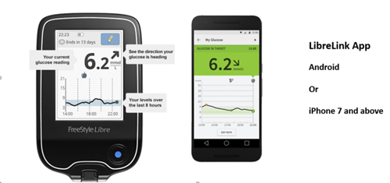Current glucose reading
* Trend arrows showing change in glucose (i.e. up or down)
* Latest 8 hours of continuous glucose data
* Low / High glucose alarms (Freestyle Libre 2)
* Range of reports to allowing longer term data analysis
* Can be shared with family / HCPs

**Data Analysis – Ambulatory Blood Glucose Profile**

In addition to familiar data such as predicted HbA1c and average glucose, the Libre can provide newer, arguably more useful, ways of looking at glucose readings over several weeks. The most useful place to start is with the Ambulatory Glucose Profile (AGP). The AGP displays large amounts of glucose data from across several days or weeks as if all the readings had occurred in a single 24-hour period – the so-called ‘modal’ day. An example display looks like this:

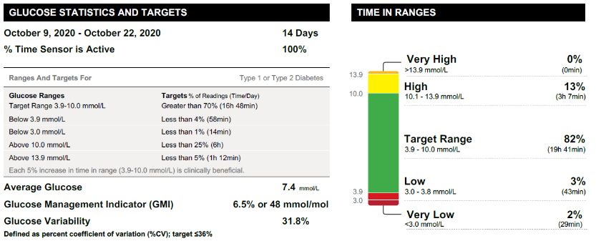

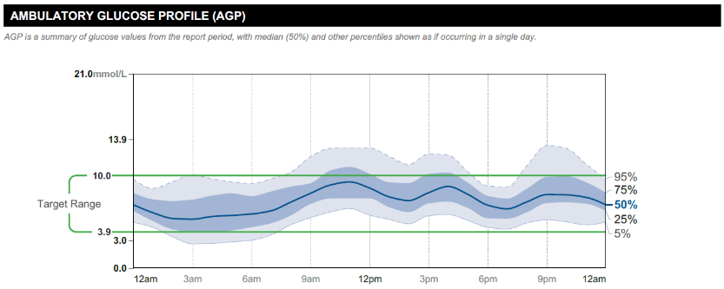

Note - The predicted HbA1c is **NOT** a substitute for a laboratory HbA1c

**Reviewing the Ambulatory Blood Glucose Monitoring Chart – an introduction**

**How much data should you look at?**

* 14 “normal” days
* Sensor active >70%

**What do the lines on the chart mean?**

* PARALLEL **GREEN LINES**: Target Glucose Range - the international consensus for AGP data analysis is a target glucose range 3.9-10 mmol/L.
* **BLACK/BLUE SOLID LINE**: Median Line – a visual trace of whether the average glucose is in the target range and how much it swings up and down at different times of the day.
* **INNER BLUE-SHADED BAND**: IQR (25-75th percentile) - i.e. the 50% of all glucose readings closest to median or where glucose levels are ‘half the time’. The wider this band is, the more variable the glucose levels are day-to-day.
* **OUTER GREY-SHADED BAND**: 10-90th percentile : more ‘occasional’ high or low glucose levels.

The most useful of the newer numbers on the display are –

**TIME IN RANGE**

* **What does it mean?** Time in range tells you the percentage of time that the patient spends within the target glucose range (usually 3.9-10.0mmol/l)
* **What is the goal?** **>70%** is the goal for most people (= HbA1c of about 53mmol/mol). However, goals are personalised eg in the older /frail / high risk person (>50%)

**TIME BELOW RANGE**

* **What does it mean?** % of time that the glucose is < 3.9mmol/l or < 3 mmol/l
* **What is the goal?** **< 4%** of the time **< 3.9mmol/l** **AND** **< 1%** of the time **< 3mmol/l**. However, goals are personalised eg in the older /frail / high risk person (<1% of the time <3.9mmol/l)