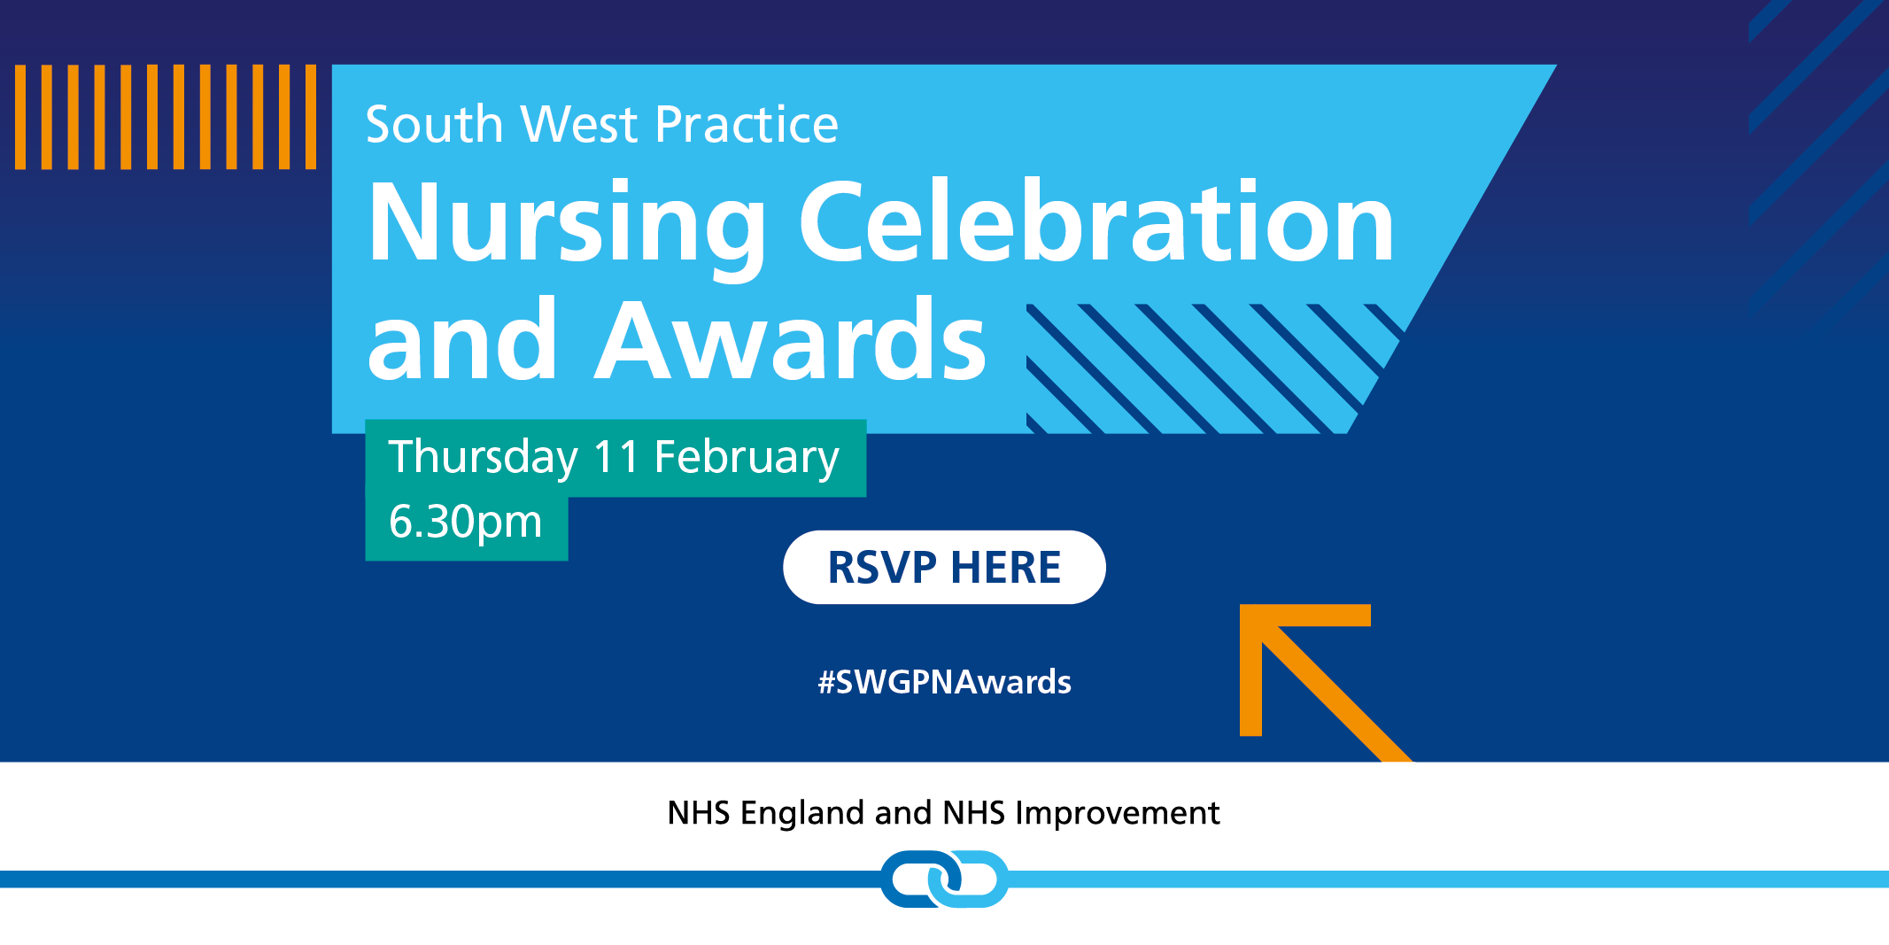

We are looking forward to welcoming you all to this free virtual event to celebrate the practice nurses of the South West.
We have an exciting evening lined up for you:

- Find out what projects have been developed in the South West for practice nurses
- Hear what your CCG or training hub has been doing in your area for practice nursing
- Listen to guest speakers from across the country explain what practice nursing means to them
- Be there for the big reveal – who will win one of eight practice nurse awards in the South West?

For your free invitation, please click here.

For more information or any problems, email jennifer.charlewood@nhs.net

