Victoria Gate Surgery
East Reach
TAUNTON
TA1 3EX

Blackbrook Surgery
Lisieux Way
TAUNTON
TA1 2LB
Tel: 01823 259444
www.tauntonvalehealthcare.co.uk

Microsuction process
‘How to’ guide
The below is a guide on Taunton Vale Healthcare’s Microsuction Clinic.
Patient groups
Group A – Patients who were not previously with ENT at Musgrove but require Microsuction. These patients require 2 failed attempts at ear irrigation at their registered GP practice before being referred.
- Once Microsuction is identified as necessary, please use the referral template that was sent to your practice (example in Appendix 1) and place on the patient’s notes.
- Book the patient straight into our clinic via the IA booking process outlined below.
Group B – Patients who have been discharged from ENT at Musgrove Park Hospital. Taunton Vale Healthcare will take on the booking in process for these patients in order of need.

Before booking patients in
Below is a list of attachments that will have been included in the initial Email sent to your practice. Please ensure that the below are downloaded and imported into Emis for our clinicians to access, and ensure continuity during consultations;
- Ear Aural Microsuction v1.1.xml - This is the Microsuction Consultation Template which must be imported onto Emis.

- Ear Aural Microsuction Consent Form v1.1.ewdt - This is the Microsuction Consent form for Emis which should also be sent to patients at the time of booking. (5ea2d8df-7482-4d0d-a2e9-0feec4bc4706.ewdt)

- Ear Aural Microsuction Patient Information Leaflet v1.1.ewdt - This is the Microsuction patient information leaflet for Emis which should also be sent to patients at the time of booking. (cc68f674-5865-4570-938c-bda9e714b634.ewdt)

- Ear Aural Microsuction Referral v1.1.ewdt - This is the Microsuction Referral Form for Emis (c63301b6-f137-4502-96df-68043aba453a.ewdt)

- Ear Aural Microsuction Discharge Summary v1.2 – This is the Microsuction Discharge Summary which must be imported onto Emis.

Please ensure that the above list is imported on to Emis before your first patient is seen at our practice.
This will ensure continuity between consultations.
Please also ensure that you have set up a Microsuction task inbox and ‘task team’ at your practice so that our clinicians can inform you if something has gone wrong with the procedure. Alternatively if your
If unsure on how to do this please follow the below steps;
Setting up a Microsuction task inbox.
- Open Emis, select ‘Configuration’ and then select ‘Organisational Configuration’

- Select ‘Teams’ on the left hand column, select ‘Add’ then ‘Add Team’
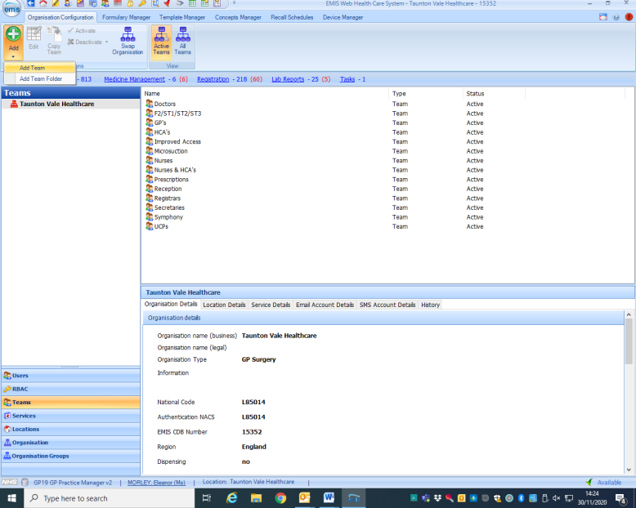

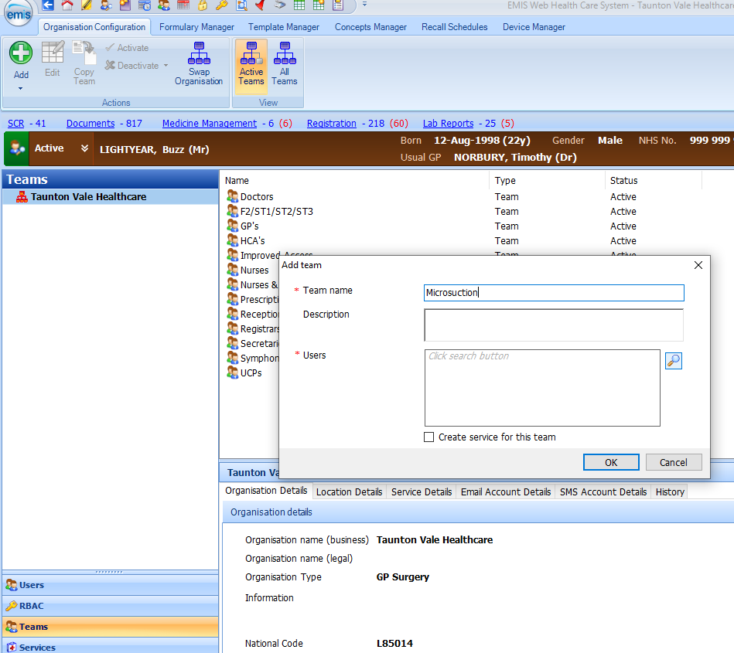
- Enter team name ‘Microsuction’

- Click the search button next to ‘Users’ and search the members of your practice who you want to manage/monitor these tasks. Double click on their name and select ‘Ok’

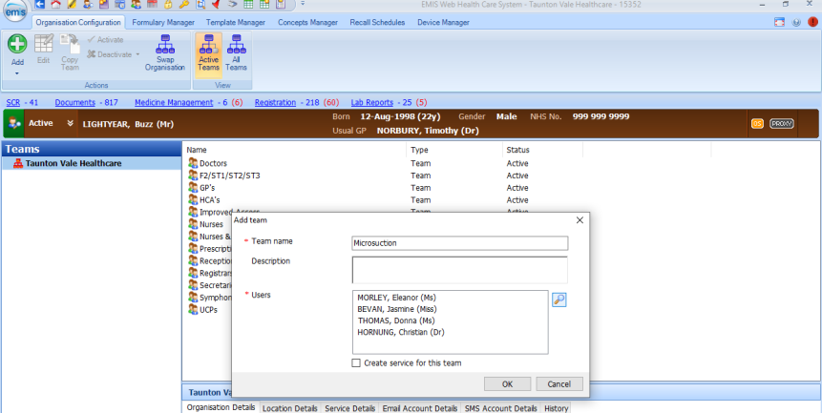
- It should look something like the below. Select ‘Ok’ and your team will have been set up.

Your practice will be tasked when the procedure has been completed. You will be informed if the procedure is unsuccessful, or if there has been a complication that you must be made aware of. Please ensure you are regularly checking your microsuction task inbox.

Booking the patient in
Below is a ‘how to’ guide on booking patients in to the available slots that we have for Microsucion.
It is the same process as is used for Improved Access (IA).
Please ensure that at the time of booking the patient in to our clinic that you give them the Patient Information Leaflet and Consent Form, as both contain important information that the patient will need to read and action before attending their appointment.
- Open your EMIS

- Type in/select the patient that requires Microsuctioning at our clinic.

- Go to ‘Appointment Book’

- Select the drop down ‘Find Slot’ and select ‘Find cross-organisational slot’

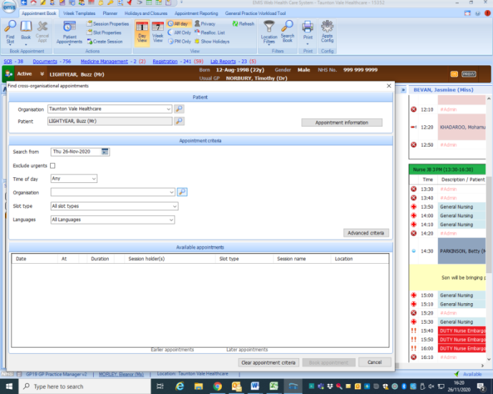
- The below box will appear. Select the search button next to ‘Organisation’

- Enter ‘Taunton Vale Healthcare into the search bar, select and click ‘Okay’
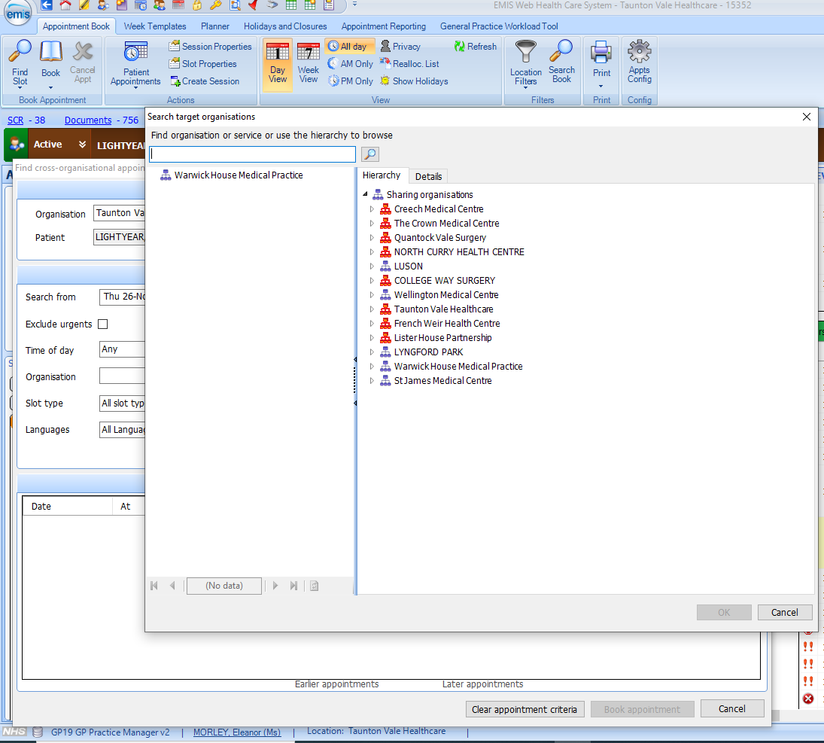

- Under ‘Slot Type’ either use the scroll bar to select ‘Microsuction’ or type it in to the search bar.
Two slot types will appear will be two slot types that appear; ‘New referrals’ and ‘ENT’ – Please only book in to the new referrals slots.
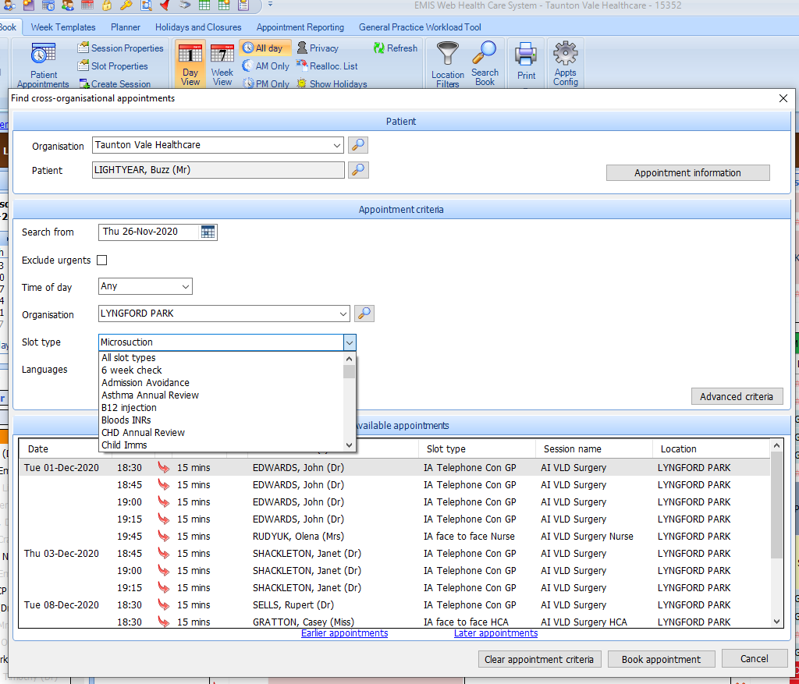

Taunton Vale Healthcare

- Select the time and date of appointment that you would like to book the patient in for in the ‘available appointments’ section and click ‘Book appointment.’
This will then appear on our systems and we will see the patient for their procedure.

Post appointment – Group A
If the appointment has been successful - A discharge summary will be placed on the patients notes (appendix 2), discharging them back to their registered GP and a task will be sent to the designated task inbox that has been set up by your practice to inform you of this. Should they require microsuction in the future they will need to be re-referred via the above pathway.
If the appointment has been unsuccessful - If the appointment has been unsuccessful it will be noted on the patient record via the discharge summary with an outline as to why. In this instance we will re-book the patient in for one further appointment at our clinic.
If the second attempt at Microsuction is unsuccessful the patient will be discharged back to their registered GP practice, whereby a clinical decision as to further treatment or a referral to secondary care will be made by their GP.
In this instance a task will be sent to your chosen ‘task team’ informing you of this.

Post Appointment – Group B
All appointments for ‘Group B’ (the patients who have been discharged from ENT) will be rebooked into future clinics by our clinical team based on need and capacity.
This group will not be discharged unless necessary, or in the instance that further care is no longer needed.
In this instance a task will be sent to your chosen ‘task team’ informing you of this.

Should you have any questions please do not hesitate to contact with Christian Hornung, GP partner
Email - chornung@nhs.net
Or
Eleanor Morley, Quality Improvement Manager.
Email – Eleanor.morley@nhs.net
Direct Dial - 01823 250231

Appendix 1

Ear Aural Microsuction Referral

- The referring clinician confirms inclusion and eligibility for this new referral according to
- The Somerset Ear Care Pathway (Appendix (1))
- Somerset CCG Evidence Based Intervention Policy: Ear Wax Removal (Appendix (2))
NB Both Options are required – otherwise the referral will need to be rejected.

- Or has your Patient been under the care of the ENT team for regular ear microsuction care? Yes

Date : Long date letter merged | Referring Clinician : Registered GP Full Name
Referring Surgery : Organisation Name | Tel No: Organisation Telephone Number
 | Email : Organisation E-mail Address

Patient Name : Full Name | Address : Home Full Address (stacked)
Contact Details : Patient Home Telephone | Patient Mobile Telephone
DOB : Date of Birth | NHS No : NHS Number

NB Please ensure contact phone numbers are up to date

Please perform microsuction : (Please state which ear or bilateral)

Additional Information :

Please ensure the patient receives a Microsuction Patient Information Leaflet

Allergies

Medication

Problems

Appendix 2

Ear Aural Microsuction Discharge Summary

Patient: | Lightyear, Buzz (Mr ) | GP: | (Dr)
 | Infinity  10 Nasa Street  And Beyond  TA1 2LB |  | Taunton Vale Healthcare  Lisieux Way  Taunton  Somerset  TA1 2LB

Date of Birth: |  | Clinician:
NHS No: |  | Discharging Clinician:

Date Referral Received: |  | Discharge Date:
Date of Procedure: |  | Discharge To: | Taunton Vale Healthcare

Procedure: | Microsuction | Risk Explained:
Conducted on (ear): |  | Consent Obtained
Procedure Successful: |  | Follow up arranged:
 |  | Date of rebooked appointment: | N/A

Clinical narrative/complications
Advice given to patient post procedure

Appendix 3: Somerset Ear Care Pathway

Support prevention and self care

Brief clinical assessment (could be by trained HCA or Practice Nurse) -offer removal of ear wax for adults if contributing to hearing loss (and not contra-indicated)

Use pre-treatment wax softeners, for a period beforehand
(to be defined)

Undertake ear irrigation using an electronic irrigator
If irrigation is unsuccessful after the second attempt undertake microsuction
If microsuction unsuccessful refer to secondary care
If irrigation is unsuccessful:
repeat use of wax softeners or
instil water into the ear canal 15 minutes before repeating electronic ear irrigation

