South West Practice Nurse Flu Clinic Symposium
Thursday 3rd September 12:30-13:30

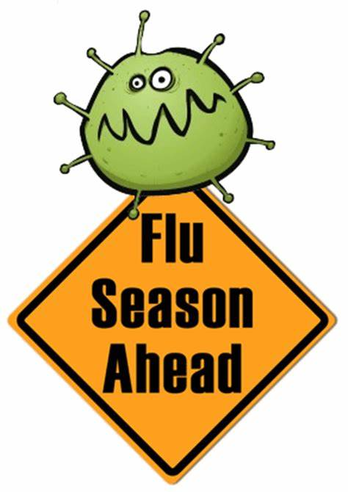
It’s that time of year again! Flu Vaccination Clinics. This year with added complexities from COVID 19. We know that you’re trying new ways of working this year, so to try and make your jobs easier we have brought some experts together for you to question.
We will also have Practice Nurses from across the South West describing their plans for their flu clinics, so we can share their great ideas.

Click here to join the MSN Teams Event.

For other queries please email jennifer.charlewood@nhs.net

