Work-Life Balance – The Wheel of Life
This week, we thought we might do a little exercise! The Wheel of Life helps us identify which aspects of life are in balance, which ones out of balance – and where the gaps are.
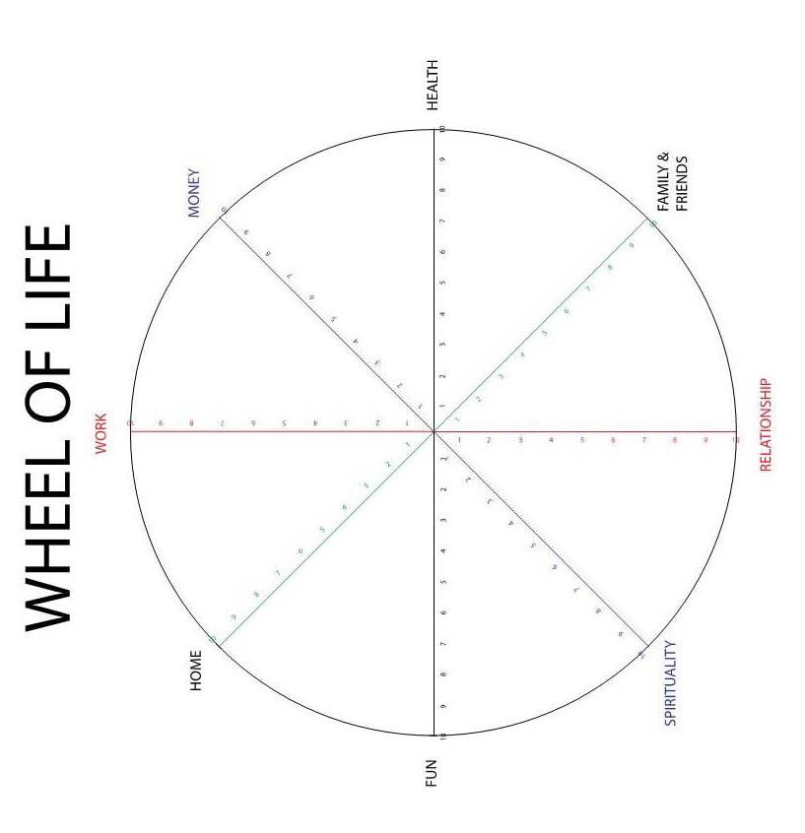
The Wheel of Life is a simple tool to help us work out how things are and how we would like them to be! Simply put a dot, on a scale of 1-10, where you estimate your current situation to be. The centre of the circle is zero, the outside 10. Then join the dots! This is your current state of being in your life. Sometimes my wheel is distinctly bumpy!
You can vary this wheel – although we suggest
- Work
- Home
- Relationships
- Spirituality
- Family and friends
- Health
- Fun
- Finance
You could also have hobbies, feeling of purpose, feeling valued or any other area you feel important.
Next, you may wish to think about your ideal work-life balance – and how would your wheel of life look then? (hint – fill in the dots for this ideal and look at how the wheel looks). How will you get from the present to your ideal? What small steps can you make towards the ideal? What changes do you need to make? Are they short term or long term?
Hint: sometimes, identifying the biggest gaps can help us focus our energy on a key area. For instance, if my kitchen is untidy and dirty, this might cause me distress. Cleaning and tidying makes me feel better in this domain – but also more productive in other areas too.
Paying attention to healthy habits, some exercise, good sleep and healthy eating may have benefits across the board – the whole wheel gets rounder and larger!
Good luck and Go Well!

