South West Regional

COVID-19 Healthcare Setting Outbreak Framework

NHS England and NHS Improvement – South West

COVID-19 Healthcare Setting Outbreak Framework

Publishing approval number: SW/EPRR/Covid-19/20200626

Version number: 1.6

First published: 26 Jun 20

Updated: (only if this is applicable)

Prepared by: Alex Thompson, Senior EPRR Manager
Dean Spencer, ICC Director

This information can be made available in alternative formats, such as easy read or large print, and may be available in alternative languages, upon request. Please contact england.sw-eprr@nhs.net.

Contents

COVID-19 Healthcare Setting Outbreak Framework 1
Contents 2
1 Introduction 3
1.1 Aim 3
1.2 Objectives 3
1.3 Scope 3
1.4 Definitions 4
2 Roles and Responsibilities 5
2.1 NHS Commissioned Providers 5
2.2 NHS Clinical Commissioning Groups 5
2.3 NHS England and NHS Improvement – South West 5
2.3.1 Regional Primary Care Team 5
2.3.2 South West Regional CoVid-19 Incident Coordination Centre 5
2.3.3 Regional Joint Incident Management Team (IMT) 6
2.3.4 Health Outbreak Oversight Panel (HOOP) 6
3 Intelligence and Surveillance 7
3.1 Intelligence Sharing 7
4 Notification, Activation and Escalation 8
4.1 Notification and Initial Actions 8
4.2 Escalation 8
4.2.1 Partial or Full Closure of Hospital site 8
4.2.2 Multiple Outbreaks within the Region 8
5 Serious Incident Reporting 9
6 Communications 9
Appendix 1: IIMARCH Template for providers other than Primary Care…………….100
Appendix 2: Outbreak Reporting Template for Primary Care…………………………15
Appendix 3: Provider, Commissioner and Regional Primary Care Team Actions….17
Appendix 4: ICC Reporting Processes……………………………….………………….21
Appendix 5: Daily CoVid-19 Outbreak SITREP – National Format…………………. 23
Appendix 6: Health Setting Covid-19 Outbreak – Daily Update Report to Regional ICC…………………………………………………………………………………………..24

Introduction

Aim
The aim of this Framework is to describe the process of notification and management of COVID-19 NHS healthcare setting outbreaks in the South West during the COVID-19 response.

Objectives
The objectives of this Framework are to:
- Support, and not replace, extant communicable disease outbreak planning and management processes that are in place across the NHS, Local Authority Public Health, and Public Health England
- Support the NHS in maintaining patient safety and quality of care at all times.
- Ensure that COVID-19 cases are reported accurately daily to the NHS South West ICC for both patients and staff.

- Ensure timely escalation of suspected outbreaks to the NHS South West Incident Co-ordination Centre (ICC), Public Health England and the local Director of Public Health.

- Describe the process for management of COVID-19 outbreaks are in line with national guidance.

- Support Patient Safety Incident Analysis or alternative investigation process.

- Ensure NHS services are supported to effectively investigate, manage and learn from outbreaks.

- Provide clarity of outbreak definitions including the declaration and ending of an outbreak in a healthcare setting.

Scope
This Framework is focused on outbreak management of COVID-19 in NHS healthcare settings during the COVID-19 response, as described in the letter 9 June 2020 “Minimising Nosocomial Infections in the NHS” and is required due to heightened interest in COVID-19 infections. These include:
- NHS Trusts and NHS Foundation Trusts
- Providers of Community and Mental Health Services
- Providers of NHS 111
- General Practices
- Opticians
- Dentists
- Pharmacy
- Health & Justice Facilities
This document is not intended to replace or duplicate other guidance, frameworks, and planning that deal with communicable disease incidents and outbreaks.
All NHS organisations should be familiar with their Outbreak Control Plans, Local Resilience Forum (LRF), Local Health Resilience Partnership (LHRP) Communicable Disease Outbreak plans and PHE or NHS guidance on Outbreak Surveillance and Management.
Additionally, NHS organisations should be mindful of the interaction with Local Outbreak Control Plans for COVID-19 produced by Local Authority Directors of Public Health as instructed by the Department of Health and Social Care on 22nd May 2020.

Definitions
In the context of COVID-19, an outbreak can be defined as the following:
- Two or more confirmed cases of COVID-19 among individuals associated with a specific setting with onset dates within 14 days,

and one of:

  - Identified direct exposure between at least two of the confirmed cases in that setting (e.g. within 2 metres for >15 minutes) or a proximity case during the infectious period of the putative index case.

or

  - when there is no sustained community transmission or equivalent Joint Biosecurity Centre risk level - absence of alternative source of infection outside the setting for initially identified cases

- A greater than expected rate of infection compared with the usual background rate for the place and time where the outbreak has occurred.

- A single confirmed case in a very high risk setting.

The definition of a cluster is two or more confirmed cases of COVID-19 among individuals associated with a specific setting with onset dates within 14 days (in the absence of available information about exposure between the index case and other cases).
The declaration of the ending of a COVID-19 outbreak in a healthcare setting, including Primary Care is as follows:
- In an inpatient setting - No confirmed cases with onset dates in the last 28 days in that setting.

- In an outpatient or Primary Care environment - No confirmed cases with onset dates in the last 28 days in that environment.

A service does not necessarily have to wait until the outbreak is closed before resuming services to patients (e.g. reopening a ward to admissions). The resumption of service is for local determination in line with PHE operational guidance on Communicable Disease Outbreak Management and local outbreak management arrangements including dynamic risk assessment by the “outbreak control team”.

Roles and Responsibilities
The roles and responsibilities listed herein are not exhaustive and related only to this Framework. Key roles and responsibilities during outbreak management are listed in Outbreak Control Plans and Outbreak Management Guidance and should be understood in conjunction with this framework.

NHS Commissioned Providers
All Providers of NHS commissioned services including Acute, Community, Mental Health, Ambulance, Learning Disability and Autism, Primary Care (including General Practice, Dental, Local Pharmacies and Opticians) and Health & Justice are to ensure they have current Outbreak Control Plans, adhering to all statutory regulations and guidance as set out therein.
In response to any confirmed outbreaks, NHS Providers will bring together an Outbreak Control Team as defined by their Outbreak Control Plans.
Providers will be responsible for submitting the required initial CoVid-19 Outbreak IIMARCH report (Information, Intent, Method, Administration, Risk Assessment, Communications and Humanitarian Issues) and subsequent daily CoVid-19 Outbreak Situation Report (SITREP).

NHS Clinical Commissioning Groups
NHS CCGs will work with their Providers to ensure robust processes are in place for the identification and management of outbreaks within their systems.
Where CCG have delegated authority for General Practice, the CCG will be responsible for submitting the required initial CoVid-19 Outbreak IIMARCH report and subsequent daily CoVid-19 Outbreak SITREP.

NHS England and NHS Improvement – South West

Regional Primary Care Team
The Regional Primary Care team will be responsible for submitting the required initial CoVid-19 Outbreak IIMARCH report and subsequent daily CoVid-19 Outbreak SITREP for all non-delegated General Practice and all Dental, Optometrist and Local Pharmacy reports in the South West Region.

South West Regional CoVid-19 Incident Coordination Centre
The NHS South West Regional CoVid-19 Incident Coordination Centre (ICC) will provide a focal point for the reporting of suspected or confirmed outbreaks and will ensure all partners are informed and involved as per this document.
The Regional ICC will be responsible for collating all IIMARCH and daily SITREP activity and following approval from the Regional Health Outbreak Oversight Panel (HOOP), publish IIMARCH Outbreak returns and Daily Outbreak SITREPs to the national Single Point of Contact (SPOC).
The Regional ICC will produce a daily Agenda for the HOOP and take action points to record actions taken. The standing HOOP Agenda will include:
• Matters arising
• Review of new IIMARCH reports
• Review of SW CoVid-19 Data Packs
• Review of the new PHE Early warning System (once available).

Regional Joint Incident Management Team (IMT)
The Joint South West IMT will provide support into systems and providers for the management of any outbreaks, as requested and agreed.
The Joint South West IMT will provide a single daily point of reference for assessment of any intelligence or information of interest in relation to risks of potential outbreaks.
The Joint South West IMT will receive a report from Health Outbreak Oversight Panel (HOOP) at each meeting.

Health Outbreak Oversight Panel (HOOP)
The NHS South West Health Outbreak Oversight Panel (HOOP) will be brought together to respond to any reported instances of potential or confirmed outbreaks.
The NHS South West HOOP will comprise of representatives from the following teams:
- Clinical (Chair)
- IPC
- ICC Director
- Analytics
- Emergency Preparedness, Resilience and Response
- Communications
- PHE
Depending the number and nature of the outbreaks the following may be invited to attend such as Supplies (PPE), UEC and Primary Care.
The NHS South West HOOP will review the information available from all sources and determine in liaison with the System and Provider if any further action or support is required from the NHSE/I Regional team.
The NHS South West HOOP will report their findings, advice and decisions back through the Joint South West IMT for further consideration, discussion, or action.
The role of NHS South West HOOP is to:
- To coordinate the reporting of CoVid-19 outbreaks.
- Use surveillance data available from providers, systems, regional and national data to identify patterns that may suggest an outbreak is happening.
- To agree how the issues identified from the surveillance data will be investigated and timescales for reporting back
- To oversee the reporting of outbreaks to the national ICC.
- To co-ordinate support to NHS organisations and systems for the effective management of outbreaks.
- To provide advice to the Joint SW IMT on the effectiveness of the control of the outbreak.
- To advise SLT on NHS organisations in the South West region with compliance with regulatory and assurance frameworks.
- To provide advice and assurance that communication to patients and the public is appropriate and timely.
The HOOP may also be established in response to any suspected outbreak within an NHS provider setting or be established in response to a decision point within the daily Joint South West IMT calls based on the intelligence and data provided by NHS and PHE.
2.3.4 Role of SLT and the Regional Director
The Regional Director and SLT will oversee the support required to manage the outbreak at a System level and will coordinate the required resources to support the local or System Outbreak management plan.

Intelligence and Surveillance

Intelligence Sharing
Various NHSE/I Regional Cells and Teams will have sources of soft intelligence and touch points with Providers and systems that may be pertinent in identifying potential risks of outbreaks. One primary source of this data will be the daily COVID-19 analytics.
Information and data will also be available through National routes into the Regional ICC and other Regional teams.
Further intelligence on outbreaks is likely to be made available through regional Public Health England team.
The daily Regional Joint SW IMT will bring together this ‘intelligence’ picture by way of updates to the meeting.
Any member of the Joint SW IMT can raise concerns with regards to intelligence at the daily meetings. This information will be considered at the next HOOP or a separate HOOP convened due to the need for immediate escalation and consideration.

Notification, Activation and Escalation

Notification and Initial Actions
NHS Providers, Commissioners and the Regional Primary Care Team will notify the NHS South West ICC (england.sw-incident1@nhs.net) of any suspected or confirmed outbreak of COVID-19 within 24 hours using the IIMARCH template at Appendix 1 for Providers of NHS commissioned services including Acute, Community, Mental Health, Ambulance, Learning Disability and Autism and Health & Justice, or Appendix 2 for all Primary Care commissioned services including General Practice, General Dental Practice, Local Pharmacists and Optometrists.
The actions to be undertaken by Providers, Commissioners and the Regional Primary Care Team in reporting outbreaks can be found at Appendix 3.
The actions required of the ICC in coordination the management of the initial CoVid-19 Outbreak IIMARCH and the production of the daily CoVid-19 Outbreak SITREP can be found at Appendix 4.
The format of the national CoVid-19 Outbreak SITREP can be found at Appendix 5.
The format of the regional Daily data capture from Providers and Primary care is at Appendix 6.
Additionally, the ICC Director is to ensure that the Regional PHE team, relevant LRF and Local Authority Director of Public Health (DPH) is informed of any significant Outbreak, whose management is likely to result in the loss of, or closure of any NHS services is their geography. This may be undertaken by utilising the Locality Director for the LRF or via the Duty On Call Manager or Director.

Escalation

Partial or Full Closure of Hospital site
Where an outbreak is of a scale that presents a risk to patient safety it may be necessary to partially or fully close a health facility. All attempts should be made by the System to maintain services to patients and to do so in a way that balances the risks of closure and maintaining the service.
Where closure takes please, the regularity, intensity and breadth of membership of the HOOP may need to be increased and extended.
In the case of any health closures near regional borders, the ICC Director will make contact with the neighbouring Regional ICC to inform a discussion on the potential operational impacts. The National SPOC will also be regularly informed as part of the Daily CoVid-19 Outbreak SITREP.
Where a health closure may cause a potential impact to healthcare delivery in a devolved administration, this will be flagged with the National SPOC for escalation.

Multiple Outbreaks within the Region
Where multiple outbreaks occur within the Region, the HOOP will make an assessment on the need to establish any additional HOOP sub-groups with defined oversight of specific outbreaks.
For example, it may be necessary for a specific group of individuals to provide direct support to a particular outbreak whilst the HOOP continues its oversight of all simultaneous outbreaks within the Region.

Serious Incident Reporting

Serious incidents can extend beyond incidents which affect patients directly and include incidents which may indirectly impact patient safety or an organisation’s ability to deliver ongoing healthcare. In terms of Patient Safety Incident (SI) reporting during the COVID-19 Pandemic (Major Incident), Organisations should continue to report anything of concern. Clinical and professional judgement should be taken when considering what to identify as a SI. The 2015 SI Framework promotes identification and reporting of SIs based on the potential for learning, future risk reduction and the consequences of any recurrence of the incident.
Where there is any evidence that the COVID-19 infection may have been hospital-acquired and a death from COVID-19 has resulted, then there is clearly scope for learning. This is potentially a Serious Incident (and reportable under RIDDOR) if the infection was acquired due to issues in healthcare provision, such as non- compliance with IPC processes. Whether SJR, RCA or some other method is the correct format to generate that learning is dependent on the circumstances and is therefore for local decision. The scale and scope of resultant investigations should be proportionate to ensure resources are effectively used. Organisations will need to be sure that any decision making is defensible and taken openly and transparently, including in discussion with relevant patients’ families and the staff involved.

Communications

Effective communications (internal and external) will be crucial to supporting the management of any outbreak, ensuring accurate information is shared with staff, patients and stakeholders and that the risk of causing unnecessary alarm is minimised. It is vital therefore that heads of communications from Regional teams, Provider and Commissioners are involved in planning any approaches introduced to manage outbreaks. This activity will be coordinated by the Regional NHSE/I Communications team.

Appendix 1: IIMARCH Template

IIMARCH Template for Reporting NHS commissioned Services CoVid-19 Outbreak

This IIMARCH template to be completed for all Providers of NHS commissioned services including Acute, Community, Mental Health, Ambulance, Learning Disability and Autism, Primary Care (including General Practice, Dental, Local Pharmacies and Opticians) and Health & Justice.

The IIMARCH template to be immediately completed on identification of any new Covid-19 outbreak. The completed IIMARCH template is to be submitted to SW Regional CoVid-19 ICC at england.sw-incident1@nhs.net by no later than 1200 the day after the outbreak has been notified.

Organisation: |  | Organisation Lead (Director of Infection Prevention and Control or equivalent) | Name:
Site: |  |  | E-mail:
 |  |  | Telephone:
Service / ward area: |  | Public Health Lead | Name:
Date outbreak identified: |  |  | E-mail:
 |  |  | Telephone:
Date of next outbreak meeting: |  | System IPC Lead | Name:
Date and time of submission: |  |  | E-mail:
 |  |  | Telephone:
Has this outbreak resulted in the suspension of an essential service within your organisation, or closure of patient admissions to a service? (Yes/No)
Notification to PHE: |  |  | Yes/No
Please RAG rate the box on the right as to the post mitigating actions status of the outbreak:
Red = Critical service (as per BCP) not available (due to outbreak)
Amber = Services running but with disruption or significant additional strain on organisation
Green = Services running with no operational impact (due to the outbreak)

Element | Key questions and considerations | Action / Response
Information | What, where, when, how, how many, so what, what might?  Timeline and history (if applicable), key facts (including outline description of any facility affected)
 | - Initial outbreak information (1.1 to 1.11 for completion when reporting a COVID-19 outbreak for the first time)
 | 1.1 Has the organisation completed all the locally required actions in the organizations outbreak plan flowchart?
 | 1.2 Number of patients affected and tested COVID-19 positive?
 | 1.3 Number of patients swabbed/blood tested awaiting result?
 | 1.4 Number of staff affected and tested COVID-19 positive?
 | 1.5 Number of staff swabbed/blood tested awaiting result?
 | 1.6 Number of staff self isolating as a result of this outbreak (% of total organisation staff number)? | No Self-Isolating
 |  | % of Organization
 | 1.7 Number of staff showing symptoms?
 | Capacity/Impact on:
 | 1.8 Number of areas affected (e.g. ward, bay, care home, clinic rooms, beds etc)?
 | 1.9 Number of wards/areas closed to new admissions?
 | 1.10 Number of empty beds that cannot currently be utilised?
 | 1.11 Number of bed days lost?
INTENT | Why are we here, what are we trying to achieve?  Strategic aim and objectives, joint working strategy  What are your immediate interventions attempting to achieve with regard to the outbreak, in order of priority?
METHOD | How are we going to do it?  Command, control and co-ordination arrangements, tactical and operational policy and plans, contingency plans  Please include operational governance process including detail of outbreak control meetings and frequency
ADMINISTRATION | What is required for effective, efficient and safe implementation?  Identification of commanders, tasking, timing, decision logs, equipment, PPE, welfare, logistics  Please include a clear timeline for actions and interdependences including resources, capacity and confidence to deliver and mobilise actions
RISK ASSESSMENT | What are the relevant risks, and what measures are required to mitigate them?  Risk assessments (dynamic and analytical) should be shared to establish a joint understanding of risk.  Risks should be reduced to the lowest reasonably practicable level by taking preventative measures, in order of priority. Consider the hierarchy of controls and clear process for escalation.
COMMUNICATIONS | How are we going to initiate and maintain communications with all partners and interested parties?  Comms strategy including understanding of inter-agency communications, information assessment, media handling and joint media strategy and frequency of updates
HUMANITARIAN ISSUES | What humanitarian assistance and human rights issues arise or may arise from this event and the response to it?  Requirement for humanitarian assistance, information sharing and disclosure, potential impacts on individuals’ human rights
When using IIMARCH, it is helpful to consider the following:
- Brevity is important - if it is not relevant, leave it out
- Communicate using unambiguous language free from jargon and in terms people will understand
- Check that others understand and explain if necessary
- Consider whether an agreed information assessment tool or framework has been used

Appendix 2: Primary Care Template for Reporting CoVid-19 Outbreaks

This CoVid-19 Outbreak template to be completed for all Primary Care commissioned services including General Practice, General Dental Practice, Local Pharmacists and Optometrists.

The CoVid-19 Outbreak template to be immediately completed on identification of any new Covid-19 outbreak. The completed CoVid-19 Outbreak template is to be submitted to SW Regional CoVid-19 ICC at england.sw-incident1@nhs.net by no later than 1200 the day after the outbreak has been notified.

Organisation: |  | Organisation Lead (Lead Partner, Pharmacist or Optometrist or equivalent) | Name:
Site: |  |  | E-mail:
 |  |  | Telephone:
Outbreak Location (with site): |  | Public Health Lead | Name:
Date outbreak identified: |  |  | E-mail:
 |  |  | Telephone:
Date of next outbreak meeting: |  | System IPC Lead  (CCG or via Regional Primary Care Team) | Name:
Date and time of submission: |  |  | E-mail:
 |  |  | Telephone:
Has this outbreak resulted in the suspension of an essential service within your organisation, or closure of patient services? (Yes/No)
Notification to PHE: |  |  | Yes/No
Please RAG rate the box on the right as to the post mitigating actions status of the outbreak:
Red = Critical service (as per BCP) not available (due to outbreak)
Amber = Services running but with disruption or significant additional strain on organisation
Green = Services running with no operational impact (due to the outbreak)

Element | Key questions and considerations | Action / Response
Initial Report | What, where, when, how, how many, so what, what might?  Timeline and history (if applicable), key facts (including outline description of any facility affected)
 | - Initial outbreak information (1.1 to 1.11 for completion when reporting a COVID-19 outbreak for the first time)
 | 1.1 Number of patients affected and tested COVID-19 positive?
 | 1.2 Number of patients swabbed/blood tested awaiting result?
 | 1.3 Number of staff affected and tested COVID-19 positive?
 | 1.4 Number of staff swabbed/blood tested awaiting result?
 | 1.5 Number of staff self isolating as a result of this outbreak (% of total organisation staff number)? | No Self-Isolating
 |  | % of Organization
 | 1.6 Number of staff showing symptoms?
 | Capacity/Impact on:
 | 1.7 Areas affected (e.g. General Practice, Dental Surgery, Pharmacy, Optometrist)?
 | 1.8 Services suspended or closed due to CoVid-19 Outbreak?
 | 1.9 Services that remain operational?
 | 1.10 Overall impact to service provision and impact on patients?
Appendix 3: Actions to be taken by Providers, Commissioners and Regional Primary Care Team

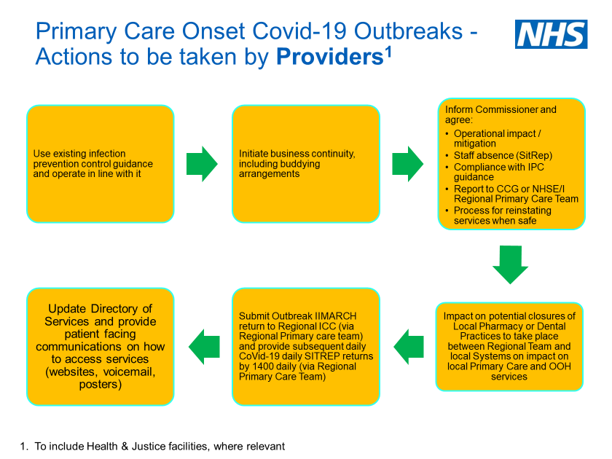
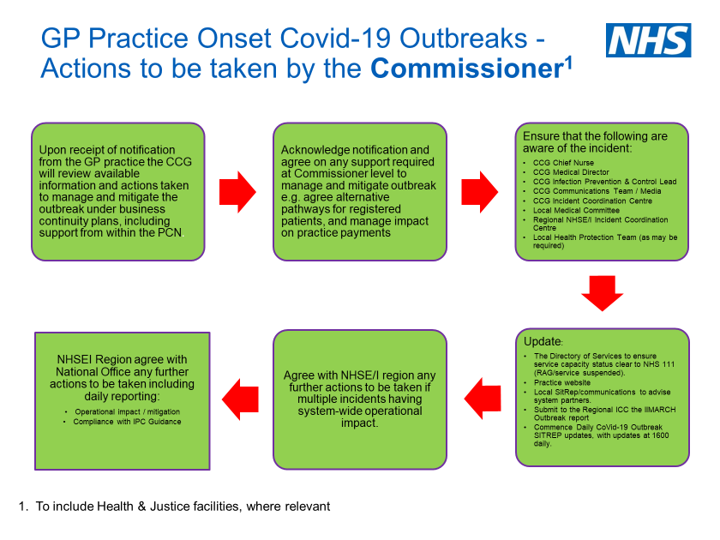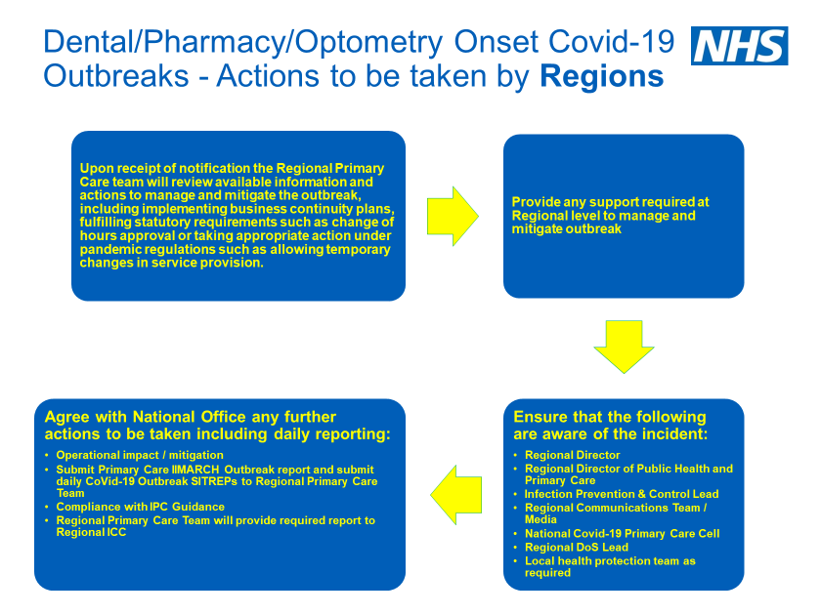

Appendix 4: Regional ICC Management of CoVid-19 Outbreak IIMARCH and Daily CoVid-19 Outbreak SITREP
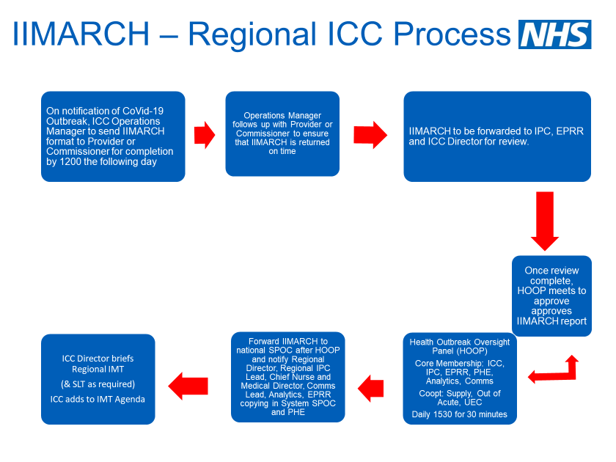
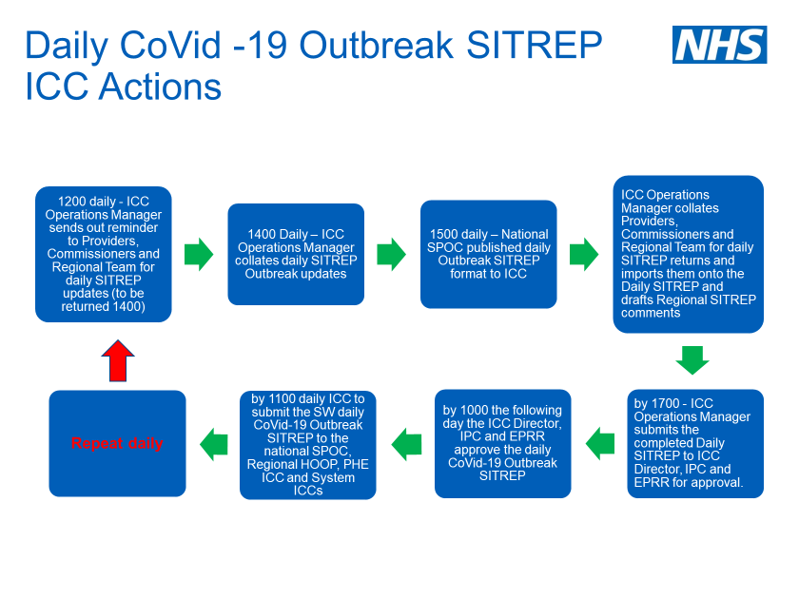
Appendix 5: Daily CoVid-19 Outbreak SITREP – National Format

Appendix 6: Health Setting Covid-19 Outbreak – Daily Update Report to Regional ICC

NHS England and Improvement - Health Setting Covid-19 Outbreak – Daily Update Report v0.7
General Information
Name of Provider:

Ward/Area with Provider:

Ward/Area Clinical Speciality

Date:

Reported prepared by name and job title:

Contact Details (should we need to get in contact Email and phone number): | Mobile
 | Email
Date of Outbreak

Date of last positive CoVid-19 test
(staff or patient)
Planned Date for Opening Ward or Area
(28/7 after last positive test)

Update

- Number of Staff Testing Positive for this outbreak (1200 yesterday – 1200 today)
How many new Covid19 positive cases in the last 24 hours:
Cumulative (to be completed by Regional ICC team and confirmed by Provider):
- Number of Staff in Isolation / Awaiting Covid 19 results (1200 yesterday – 1200 today)
Number of staff who have been placed into isolation in the last 24 hours:
- Number of Patients Testing Positive for this outbreak (1200 yesterday – 1200 today)
How many new Covid19 positive cases in the last 24 hours:
Cumulative (to be completed by Regional ICC team and confirmed by Provider):
- Number of Patients in Isolation /Awaiting Covid 19 results (1200 yesterday – 1200 today)
Number of Patients who have been placed into isolation in the last 24 hours:
- Are you on trajectory on your outbreak control plan?
Yes - What actions have you taken in the last 24 hours? What actions do you plan to take in the next 24 hours? |  |  | No - Please give details of your mitigating actions including what actions have you taken in the last 24 hours and what actions do you plan to take in the next 24 hours? (e.g. transfers of patients to another provider)
YES/NO |  | Actions:
- Have you identified any risks that could lead to increase transmission?
If Yes - How are these mitigated - what actions have you taken / plan to take? |  |  | If No - Go to question 7.
YES/NO
- Have you closed or partially closed/reduced services as a result of this outbreak?
If Yes - Please give details of the services that have been disrupted and the impact on delivery?
YES/NO | Detail:

Please provide the following information and return to the Regional ICC england.sw-incident1@nhs.net by no later than 14:00 daily.

Links: PHE guidance on defining and managing communicable disease outbreaks https://www.gov.uk/government/publications/communicable-disease-outbreak-management-operational-guidance
High Risk settings may include area were patients are immunocompromised, including Renal Dialysis and Oncology and outside of the hospital setting, they may include Residential facilities such as HMPPS facilities and specific residential healthcare facilities.

