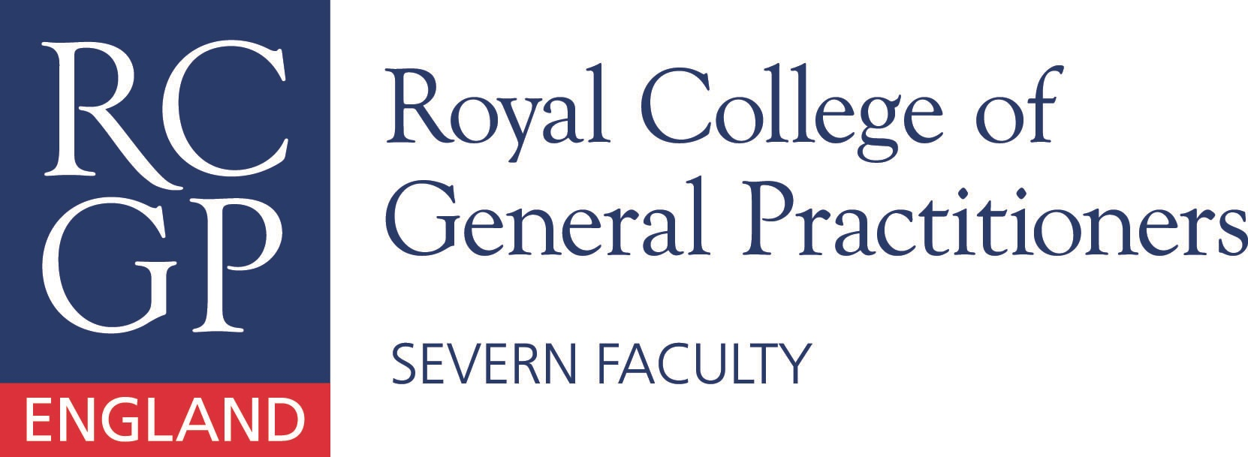

Please come along and join GPs and GP trainees with an interest in international health.

7:30pm – 9:30pm @ Engineers House, The Promenade, Clifton, Bristol, BS8 3NB. Free Parking.

Dr Liz Murphy from The Haven will give a talk on health issues relating to refugees and asylum seekers.

RSVPs and questions: severn.international@gmail.com

Welcome to Severn International

