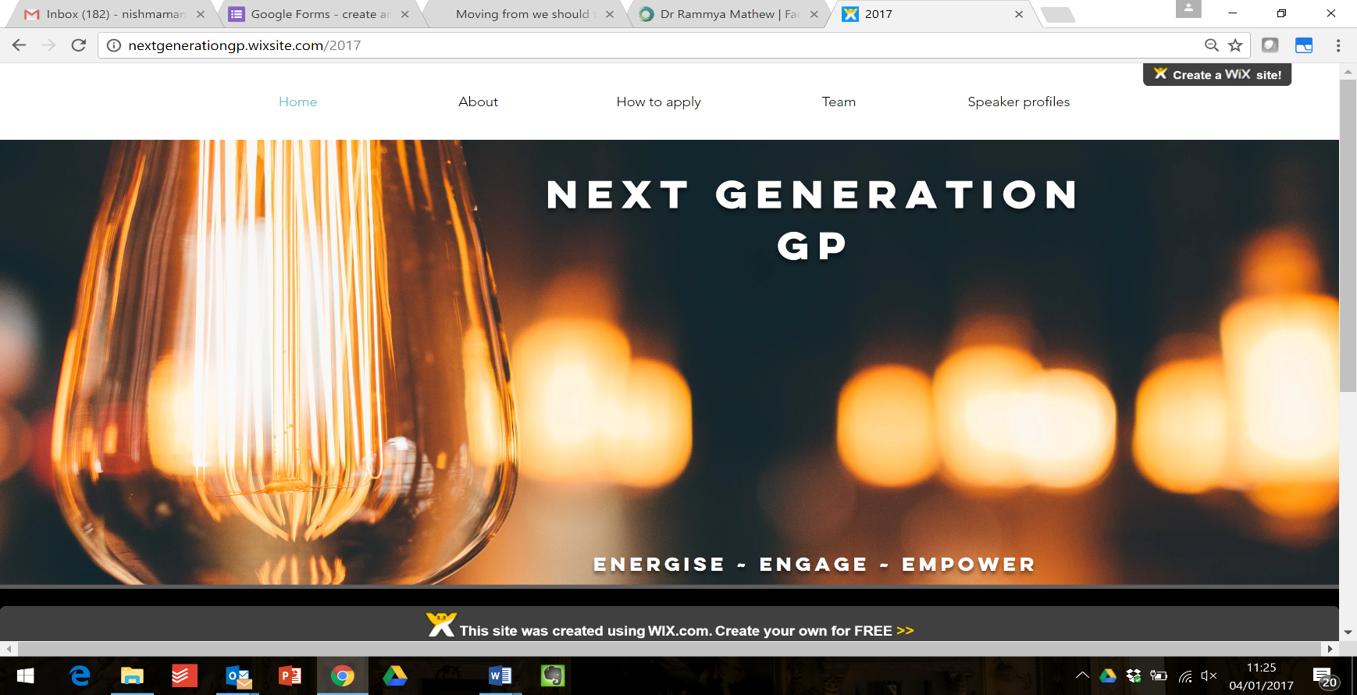
Pop-up Somerset

WHAT IS NEXT GENERATION GP?

‘Next Generation GP’ is a programme for emerging leaders in general practice designed by, and for, a group of early-career GPs and trainees designed to inspire early career GPs (trainees and first 7 years post CCT) to be informed leaders with the insight and connections they need to change and improve the system in which we work.
Our aim is for participants to feel:
- Energised: through access to the stories, perspectives and expertise of inspiring leaders at the forefront of primary care;
- Engaged: through a supportive network of like-minded local trainees and early-career GPs;
- Empowered: through a series of workshops that will begin to increase your ability to shape care within and beyond your organisation.

The pop up event

Participants will benefit from the unique opportunity to meet, engage with, and ask questions of some of the foremost leaders in the NHS. The evening is divided into two parts. The first is a themed workshop, talk or facilitated group work session addressing a specific leadership challenge. Complementing each of these will be an interview with an inspiring national leader. These events will also be a fantastic opportunity to build relationships with like-minded GPs and trainees in your area.

DATES and VENUE
- Wednesday 9th October in Taunton Racecourse Conference Centre, TA3 7BL
  - 18.00 – Dinner and networking.
  - 18.50 – Session starts.
  - 21.30 – Session ends.

How to apply

We have a limited number of fully-funded places to offer on the programme for GP trainees and early-career GPs.

Applicants are invited to submit a brief expression of interest outlining their motivation for applying:
- The person specification can be found at: http://bit.ly/nextgenspec
- The application form can be found at: https://www.surveymonkey.co.uk/r/NGGP2019Taunton

Applications for Next Generation GP Pop up Somerset are open NOW and close at 23rd September 2019.
We will aim to inform all applicants of the outcome by 1st October 2019.
If you have any questions please email: NextGenSW@gmail.com

