Galderma UK, Leo Pharma and Dermal Labs have jointly organised the following meeting and would welcome your attendance.

South Somerset Skin Club
Dermatology teaching
Hosted by

Dr Jibu Vargehese, Consultant Dermatologist & Dr Martyn Richards GPSI/Hospital Practitioner
Yeovil District Hospital NHS Foundation Trust
Date: Wednesday 1st November 2017
@ The Lanes Hotel, West Coker, Yeovil
‘Dermatology Cases - Management tips for the busy GP’
Case-orientated, interactive Dermatology Teaching, with a focus on the key management principles for a selection of both rashes and lesions.
Aims: Achieving appropriate referrals and improving chronic disease management.
Agenda;
Company representation will be at the meeting with prescribing information available

6.45pm Registration and Hot Buffet

7.15pm Teaching Session

8.45pm. Questions and Coffee,

9.00pm Meeting Close

RSVP : Confirmation of attendance would be appreciated.

Please email or phone
Alison Earp: alison.earp@galderma.com Mobile: 07949 056240

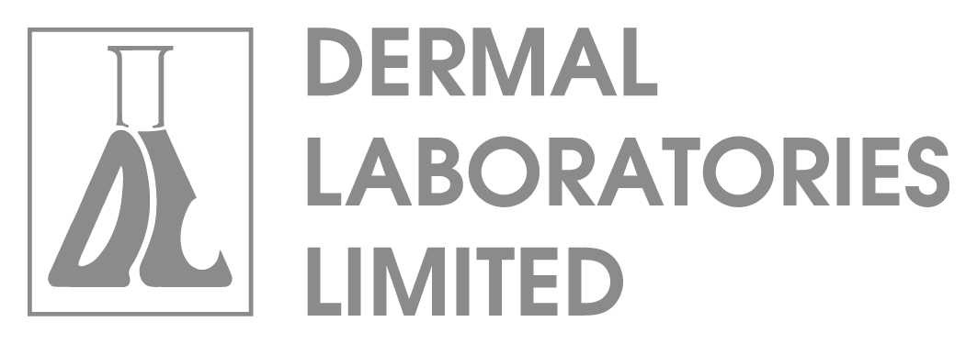
This educational event is organised & supported by the Pharmaceutical Companies Galderma UK, Leo Pharma and Dermal Labs to cover the costs of providing a venue, speakers & catering.

